**Reactjs**

**Why react?**

* Reusable components supported by react makes it top choice with writing very less code.
* Learning curve is not stiff.

**Creating a react app(vite):**

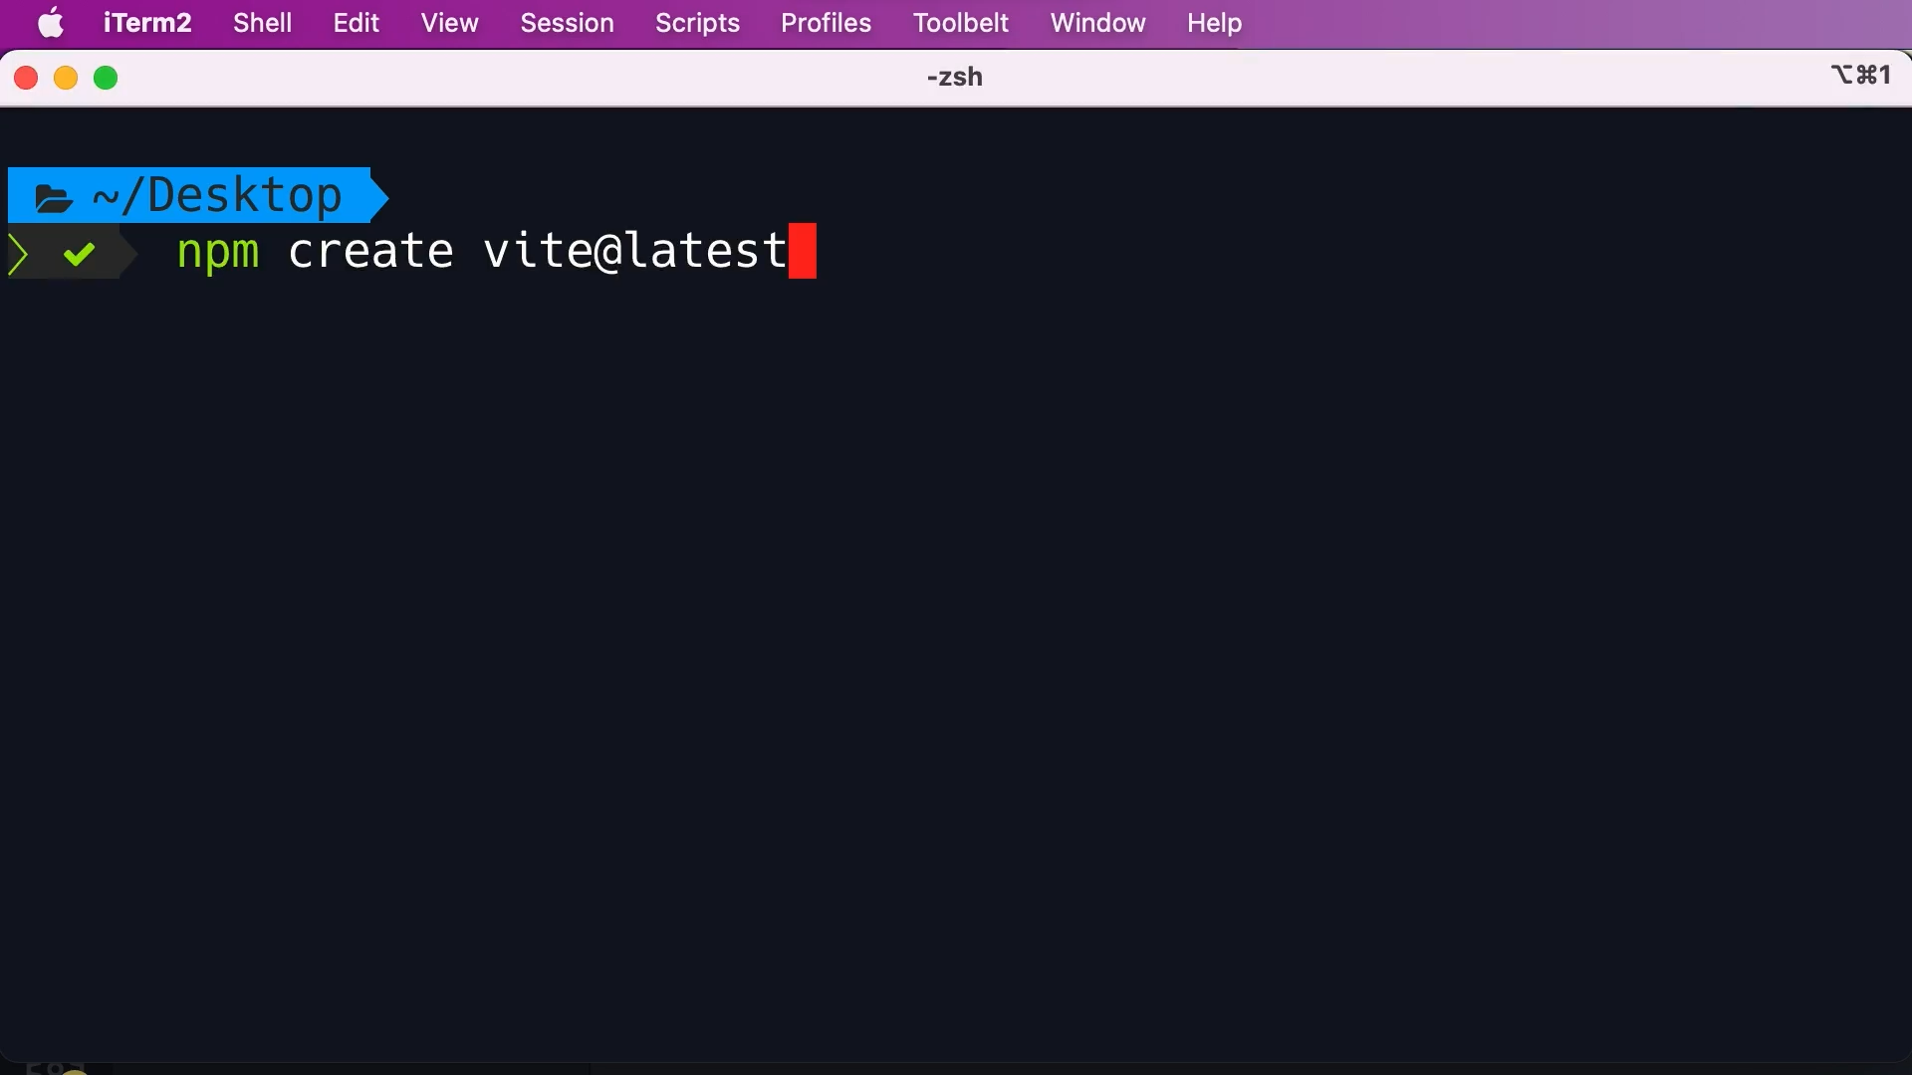

**Running application:**

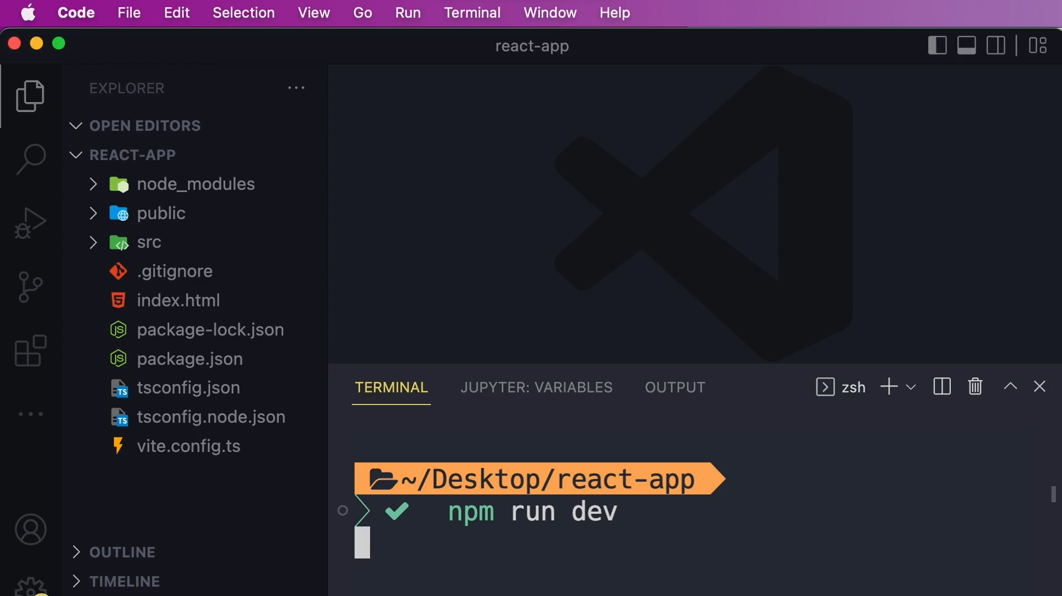

**React DOM:**

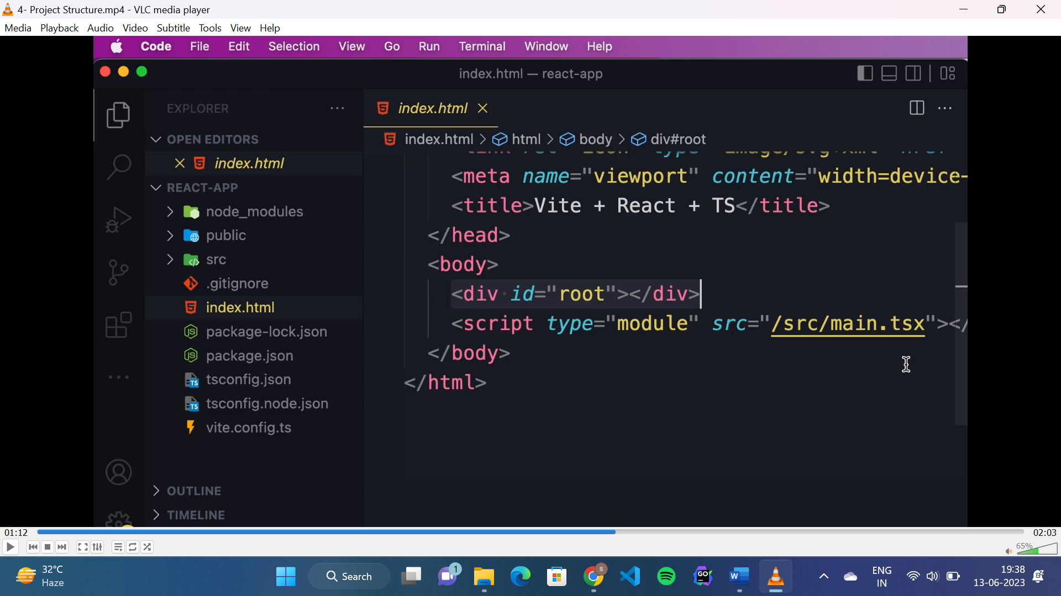

* “id=”root”” is the react container.
* “main.tsx” is the entry point of the application.

**React component:**

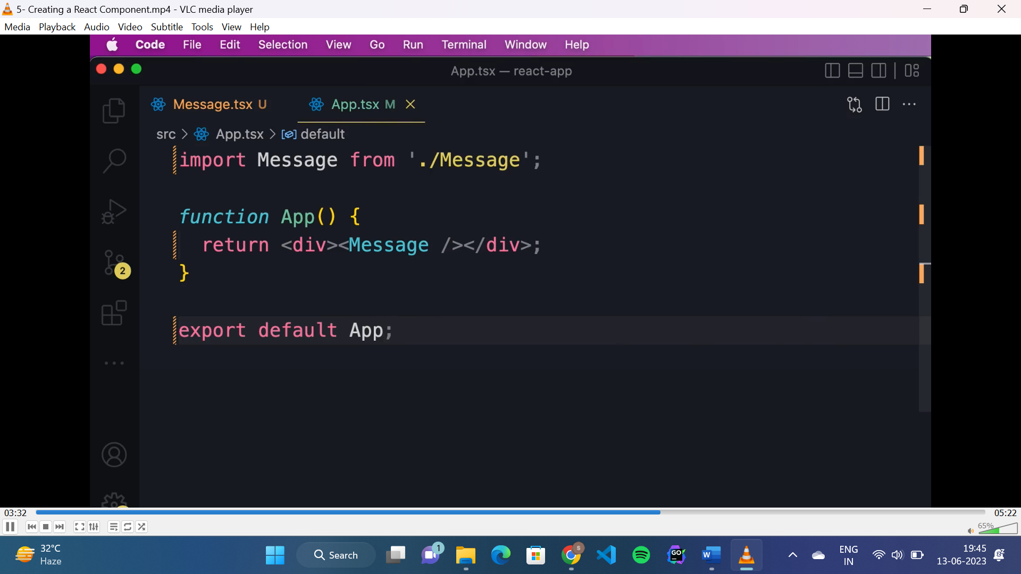

**Virtual DOM:**

* When we run application react takes the component tree structure of our application and creates JavaScript data structure called virtual DOM.
* It is light weight in memory representation of component tree.
* Here each node represents a component and its properties.
* When the state or data of component changes, the corresponding node of that component updated in the virtual DOM to reflect the new state.
* Then it will compare the current version of virtual DOM with the previous one and update those node which got changed.
* And this updating task in real DOM is done by “react DOM” library not by react.

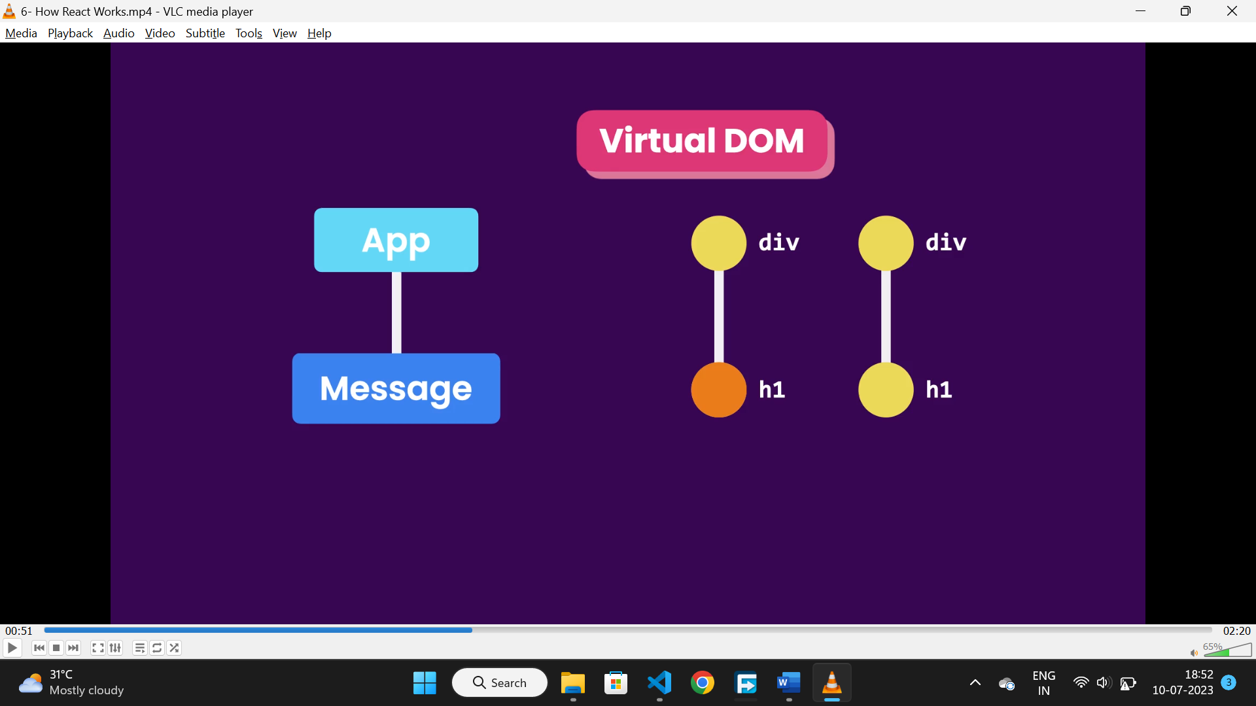

**React strict mode:**

* It is used to identify potential problems in react app.

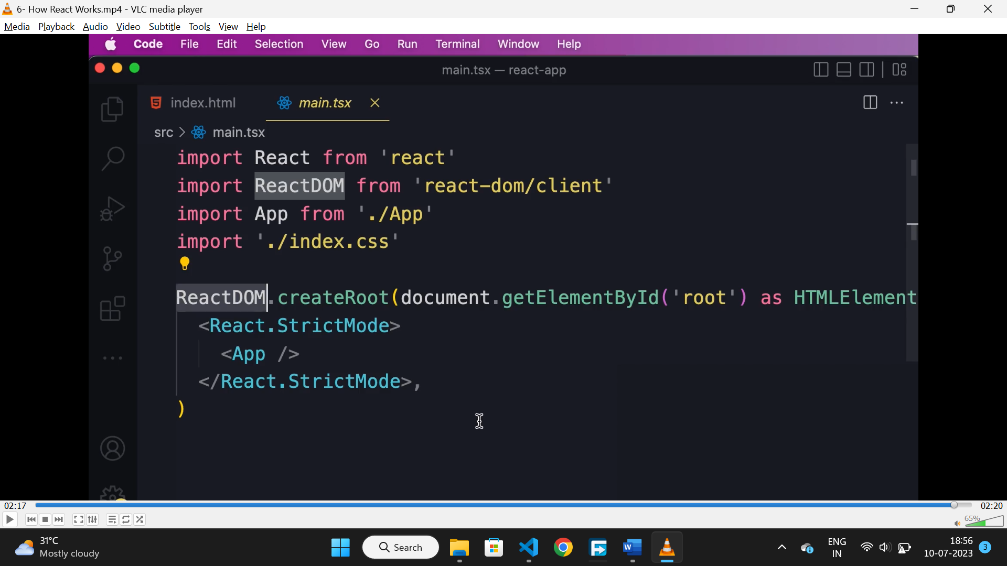

**Fragments:**

* Used to return multiple elements at a time.

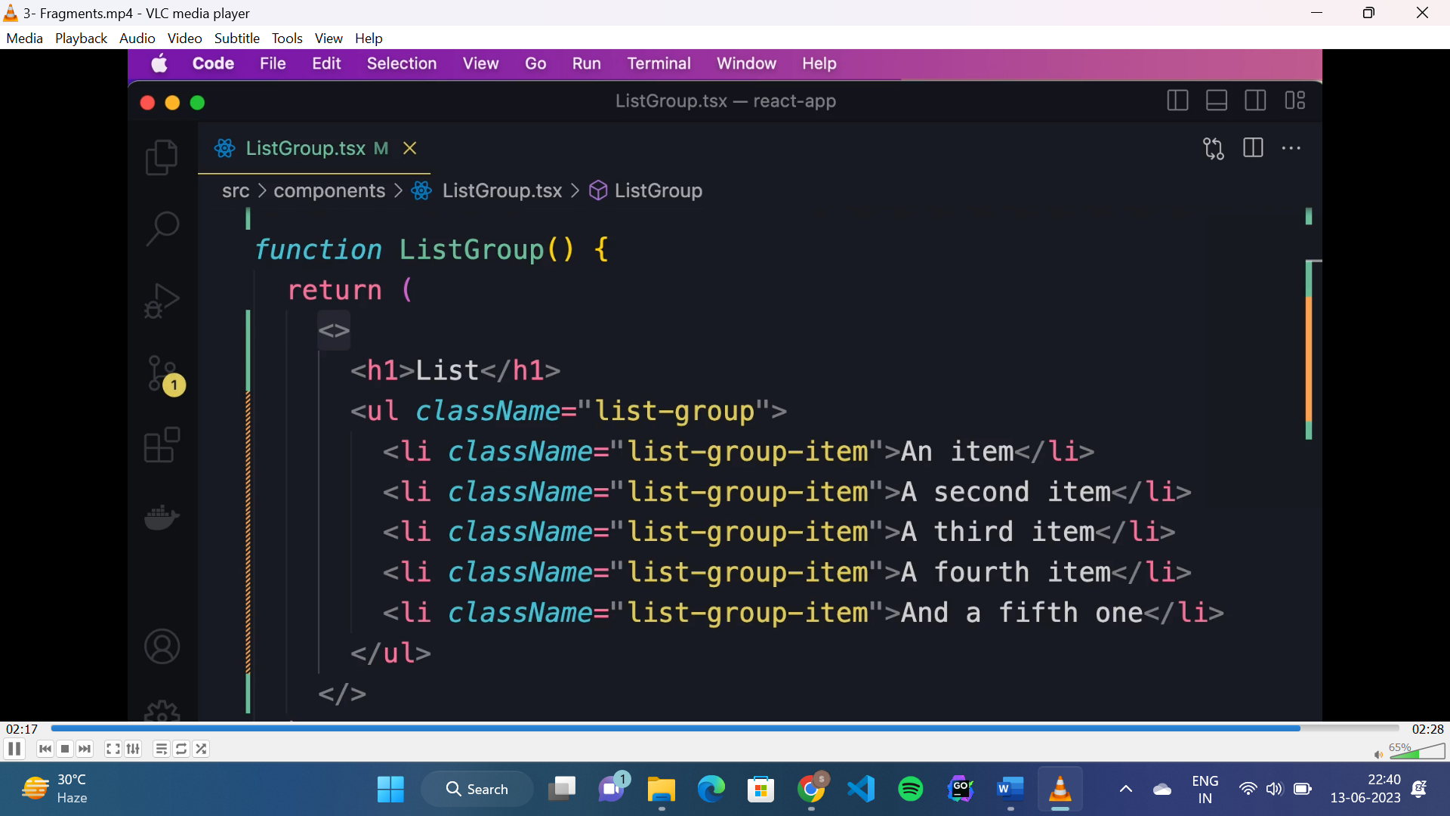

**Rendering list dynamically:**

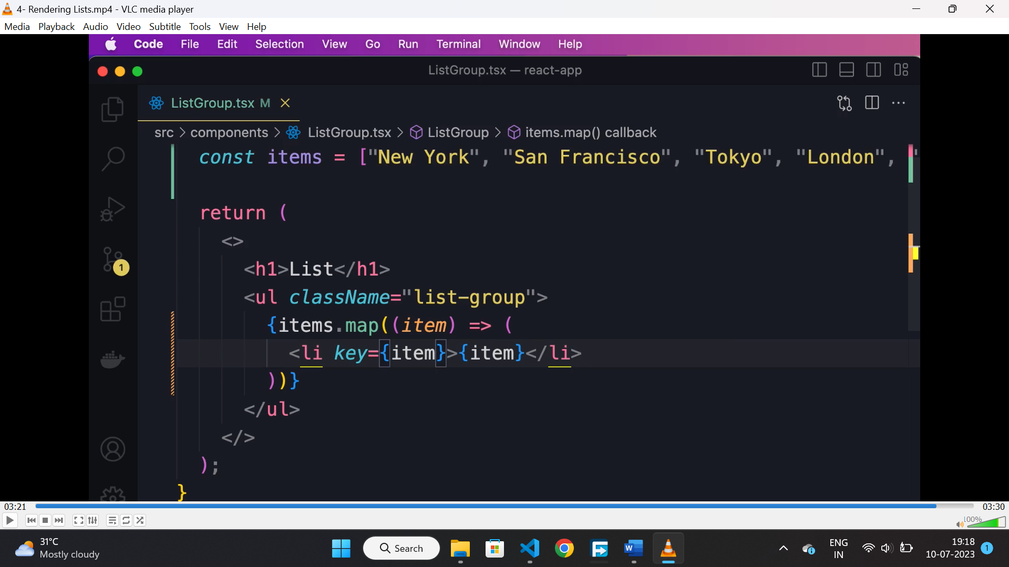

**Conditional rendering:**

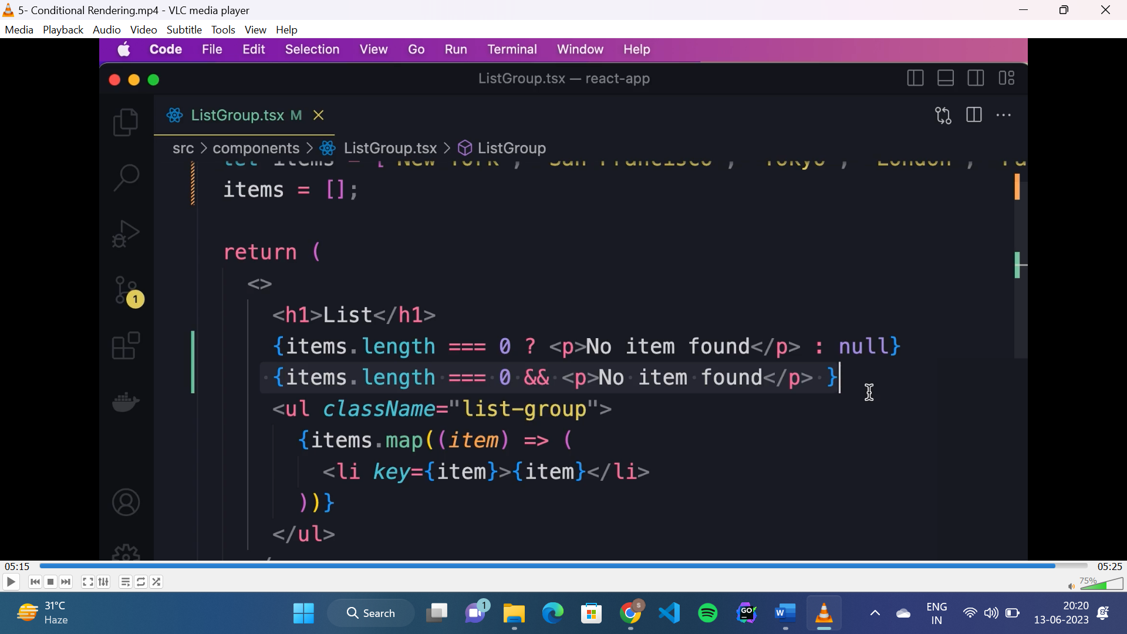

**Synthetic event:**

* It is a built in class in react because different browsers have different implementation of event object, so to make it cross browser, react made this wrapper over the browser event object.

**Handling event(TS):**

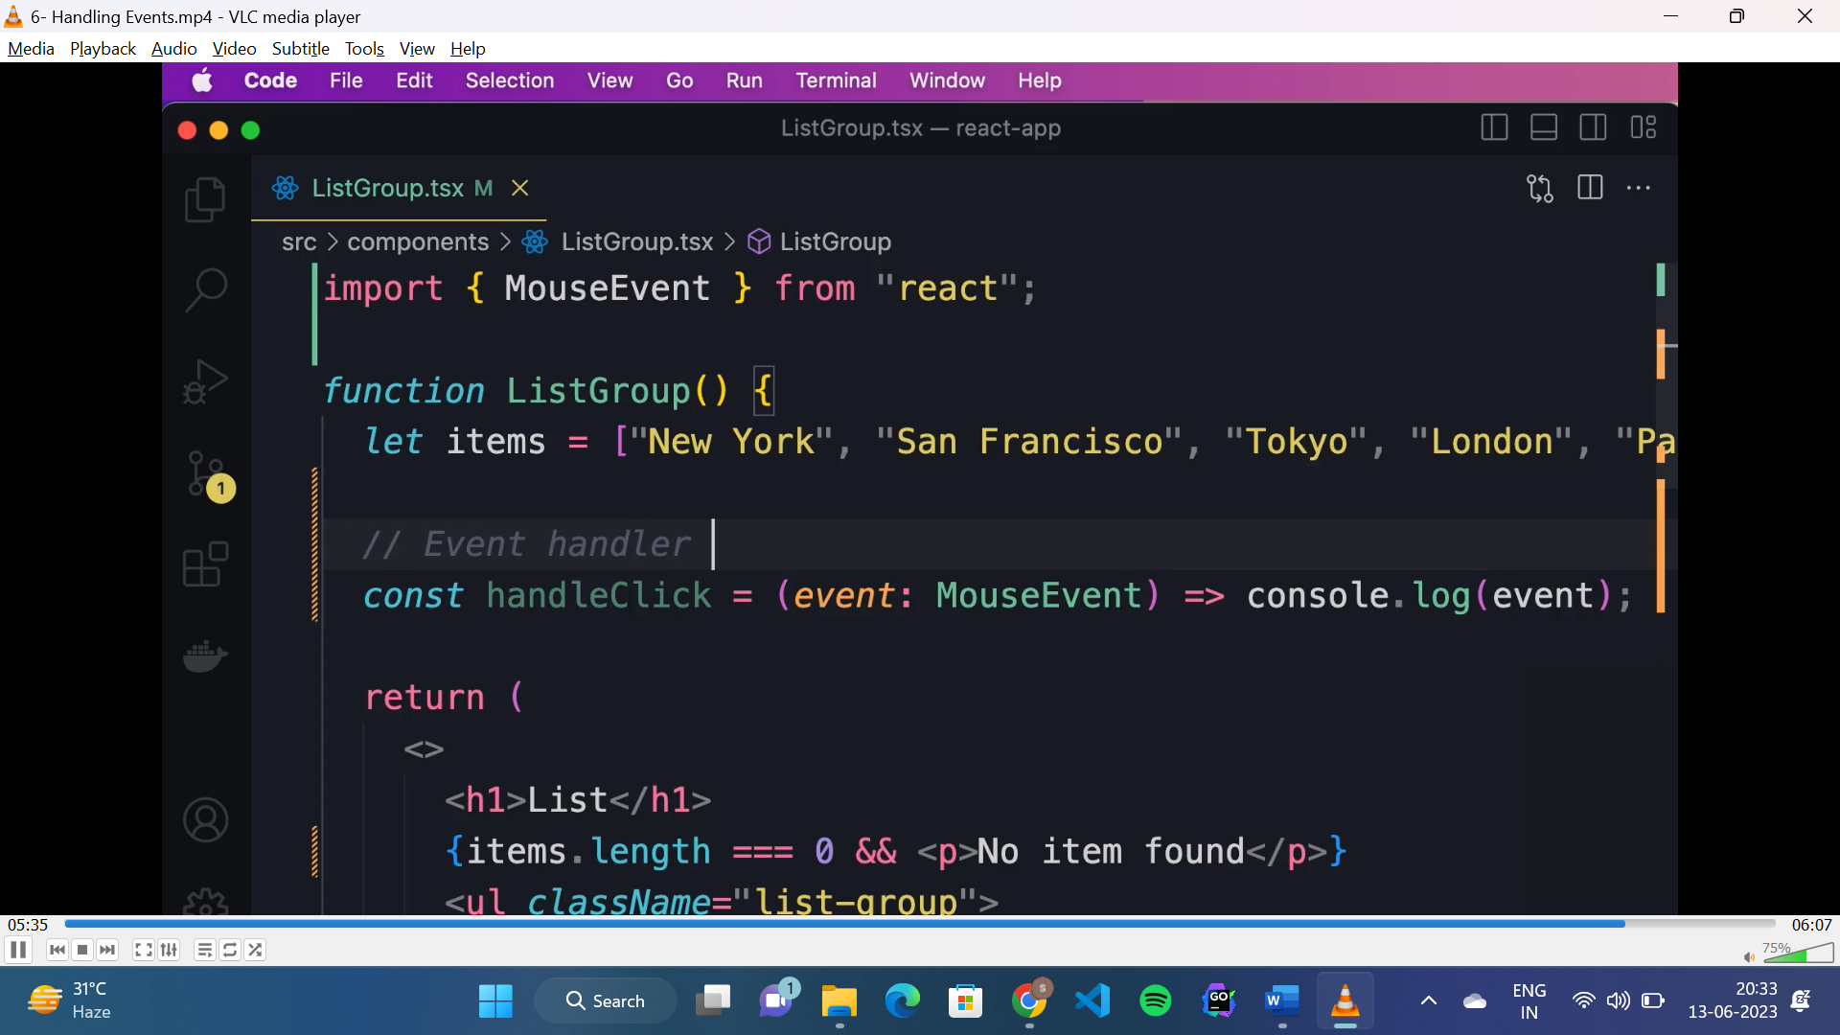

* To handle any mouse event, we need to define the event type as “event: MouseEvent”.

**Dynamically applying “active” class:**

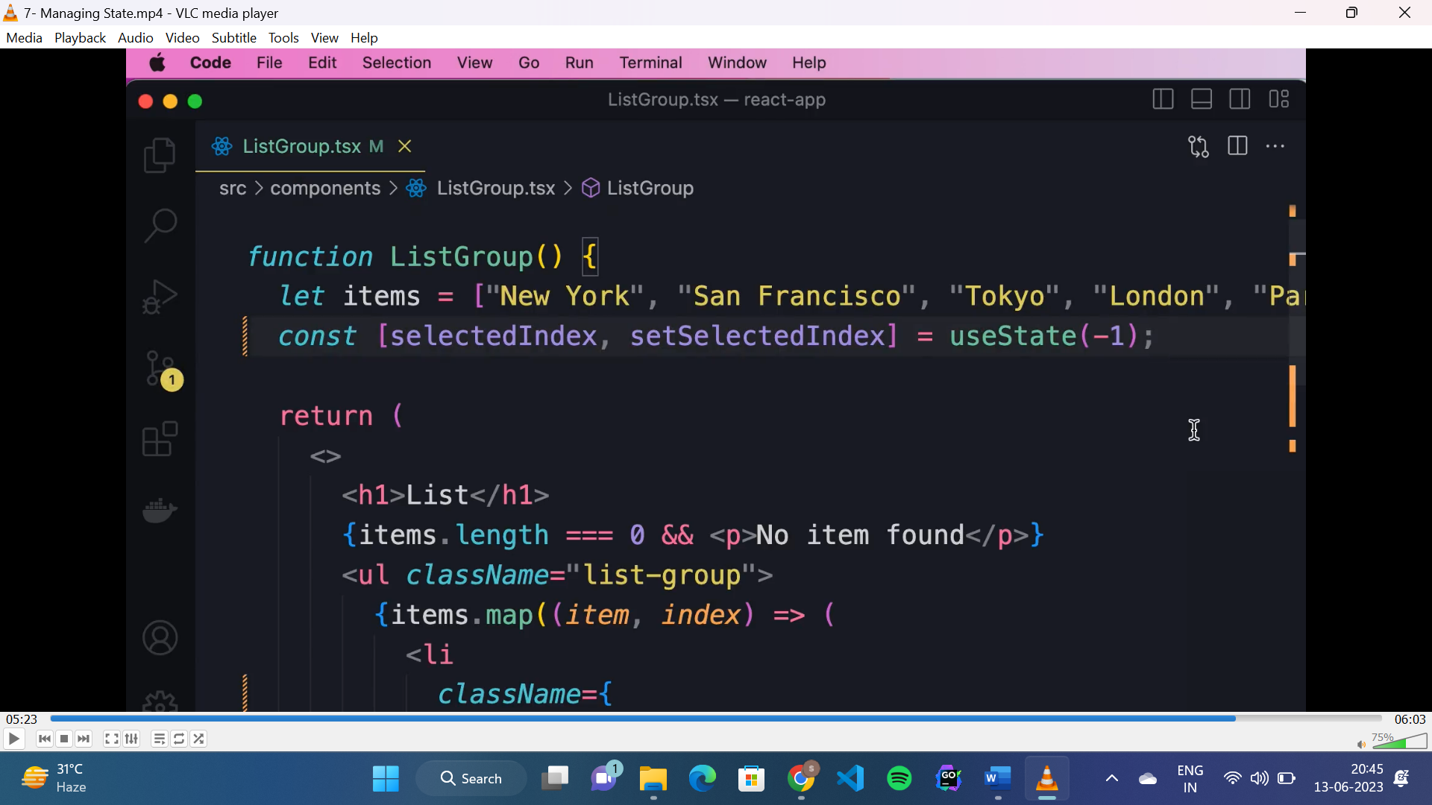

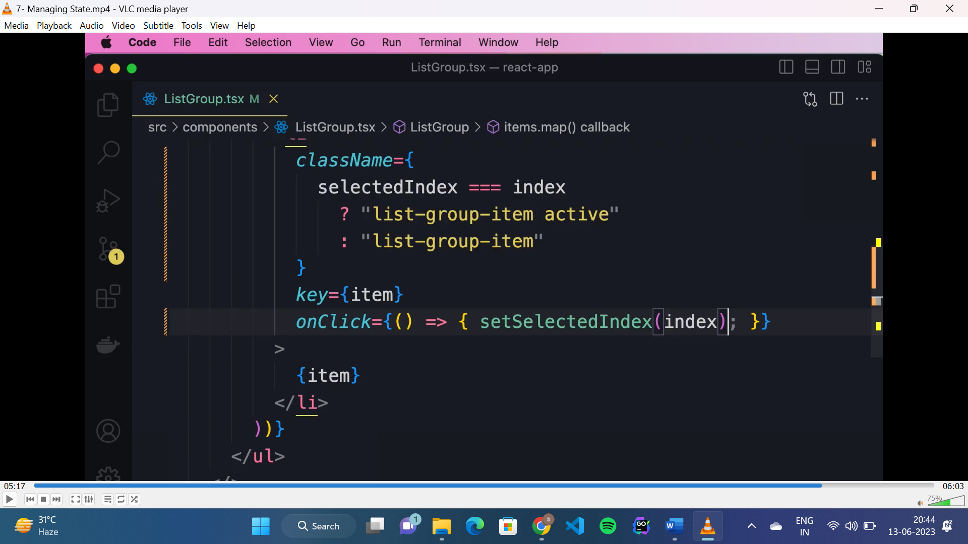

**TS interfaces:**

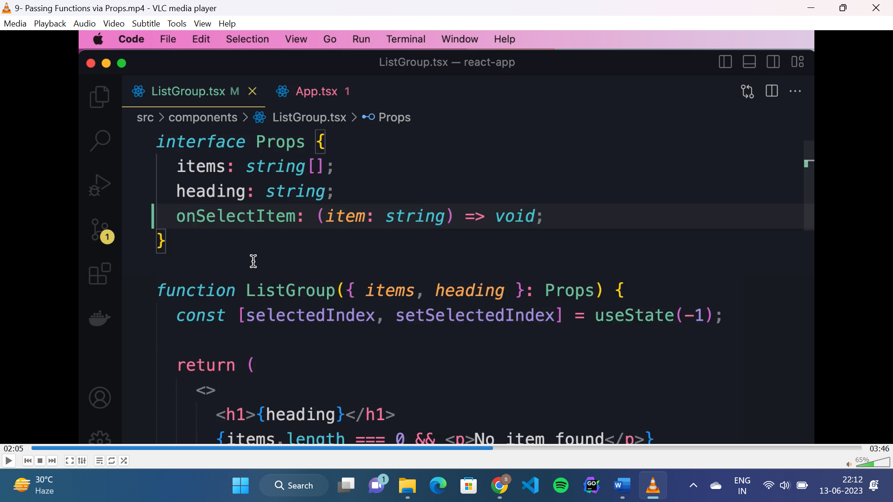

* Interfaces are used to define the shape of the input values(props) passed to a component.
* Starts with capital letter.

**Children prop:**

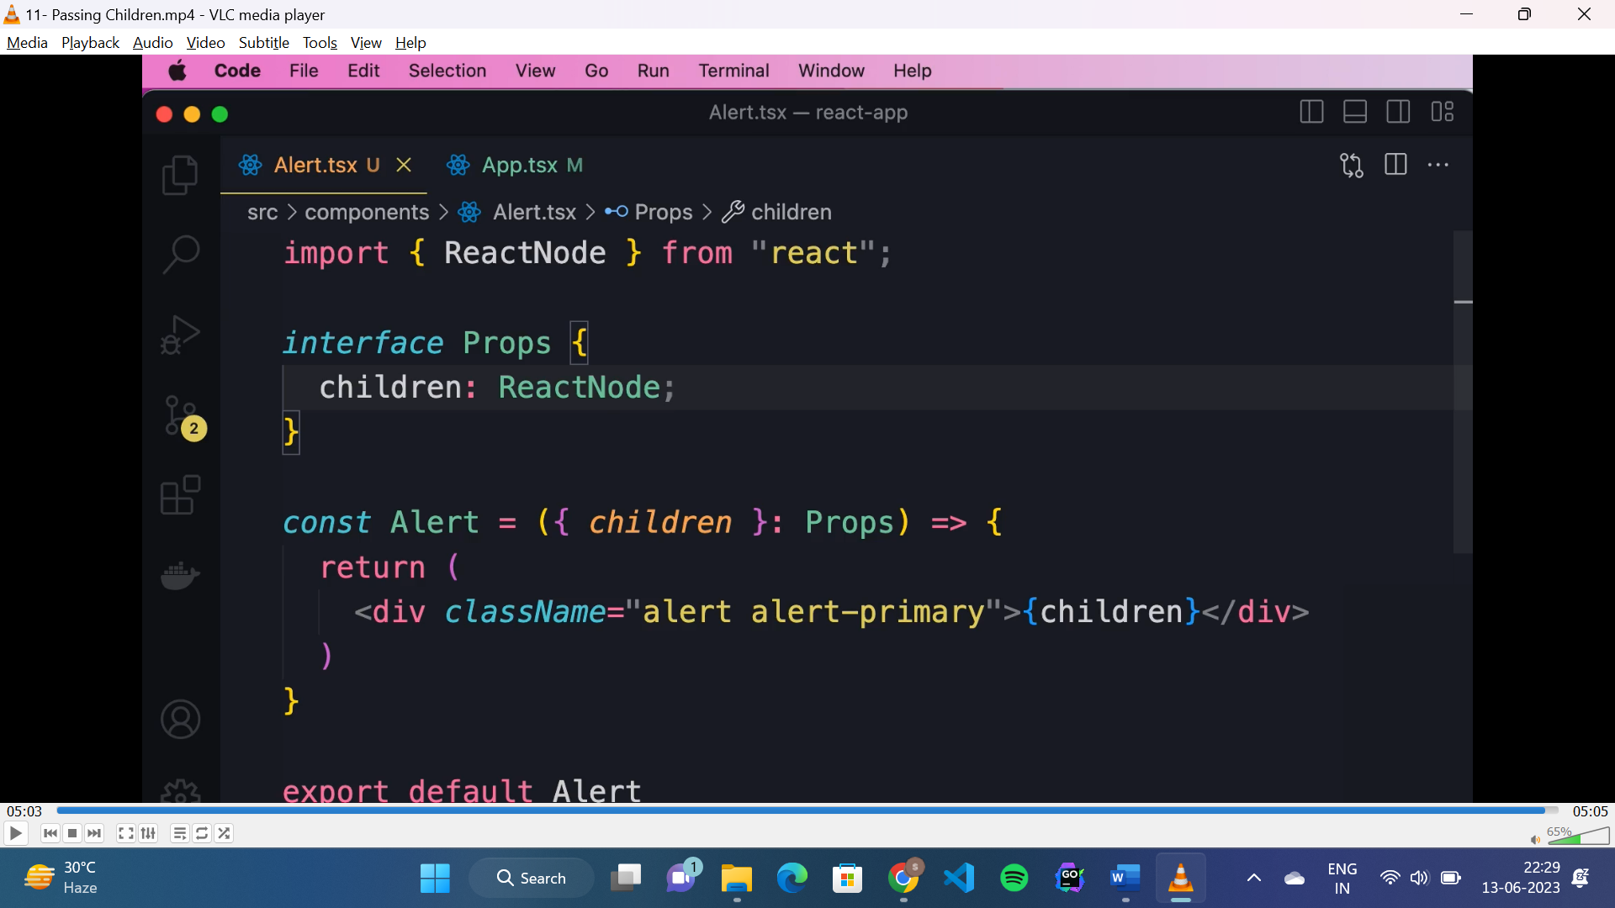

* To pass children as prop to a component:
* If it is a text: “children: string”
* If it is a HTML: “children: ReactNode”

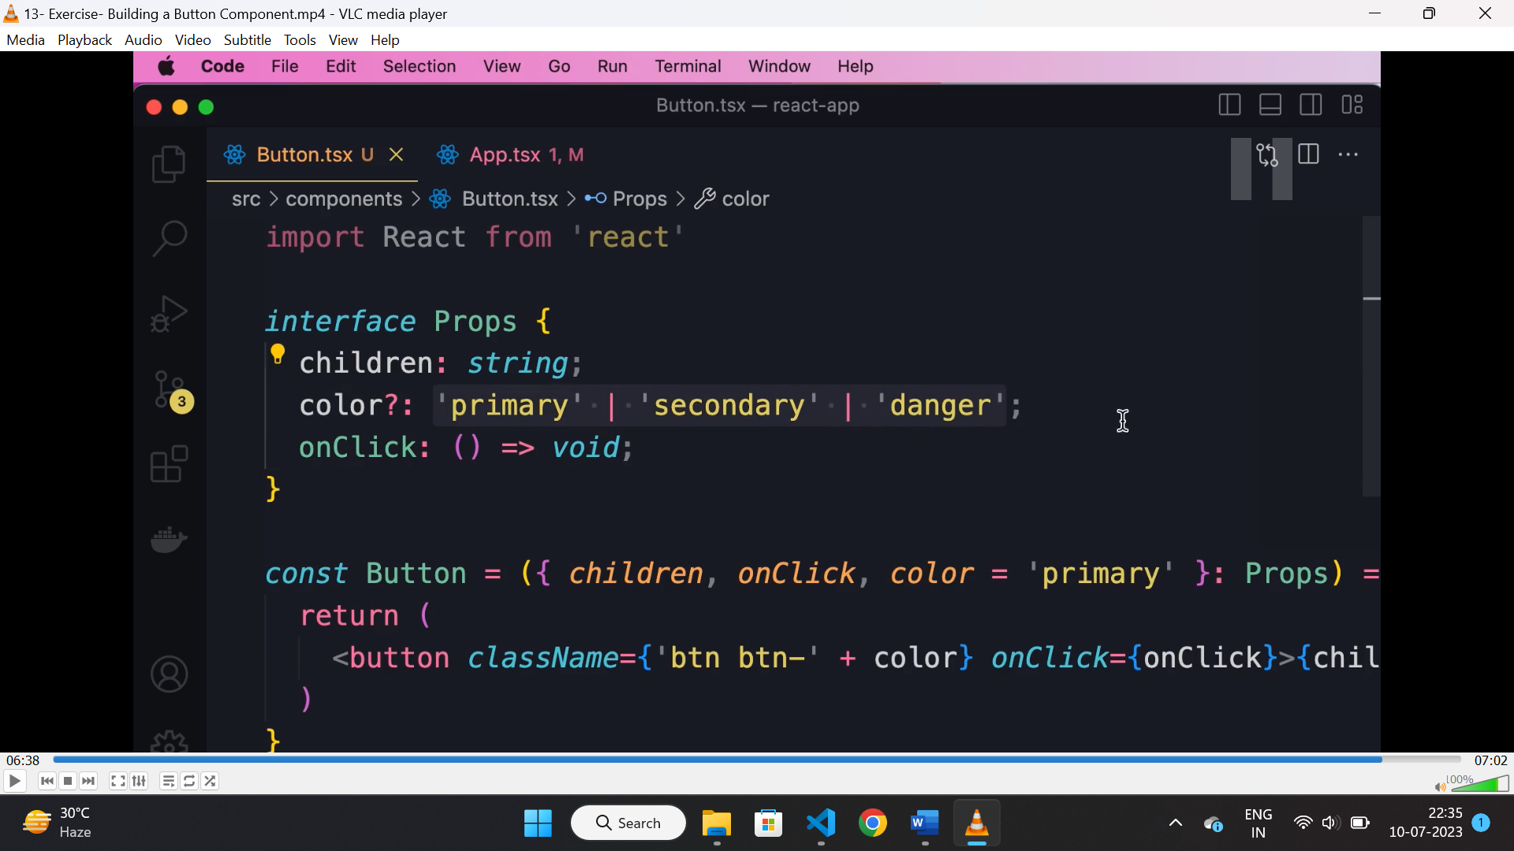

* In above interface “color” is a optional prop, and the value should be any of the values given.

**Props vs state:**

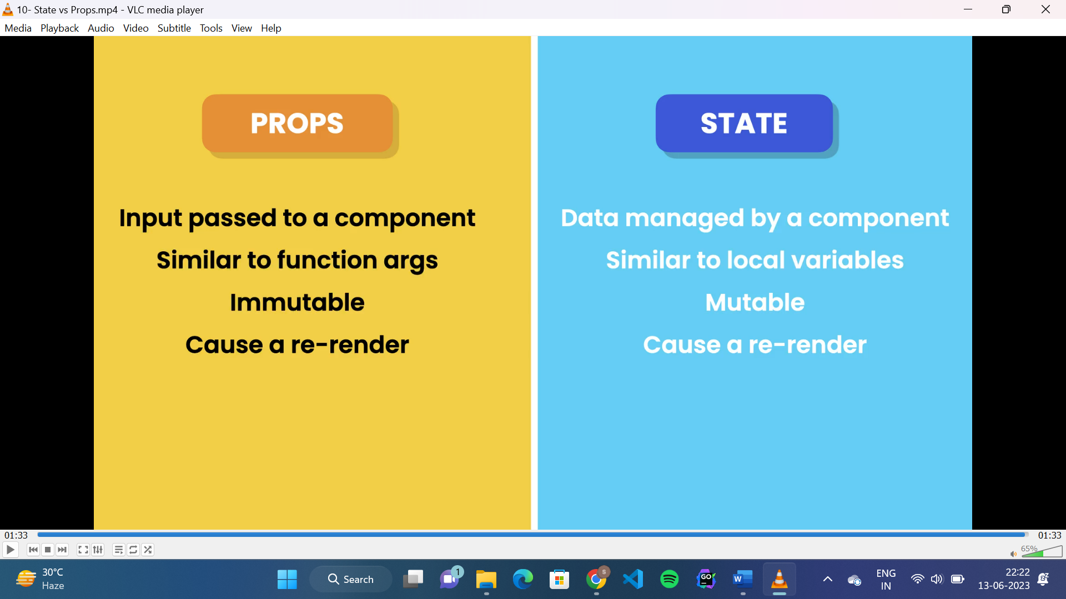

**Styled component:**

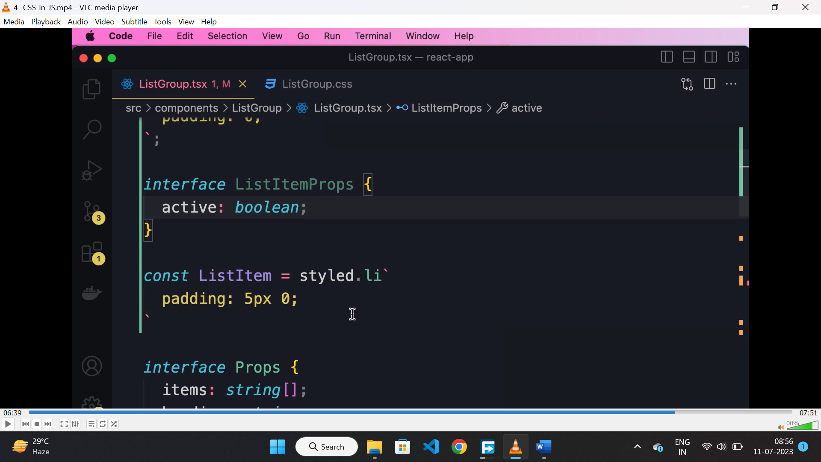

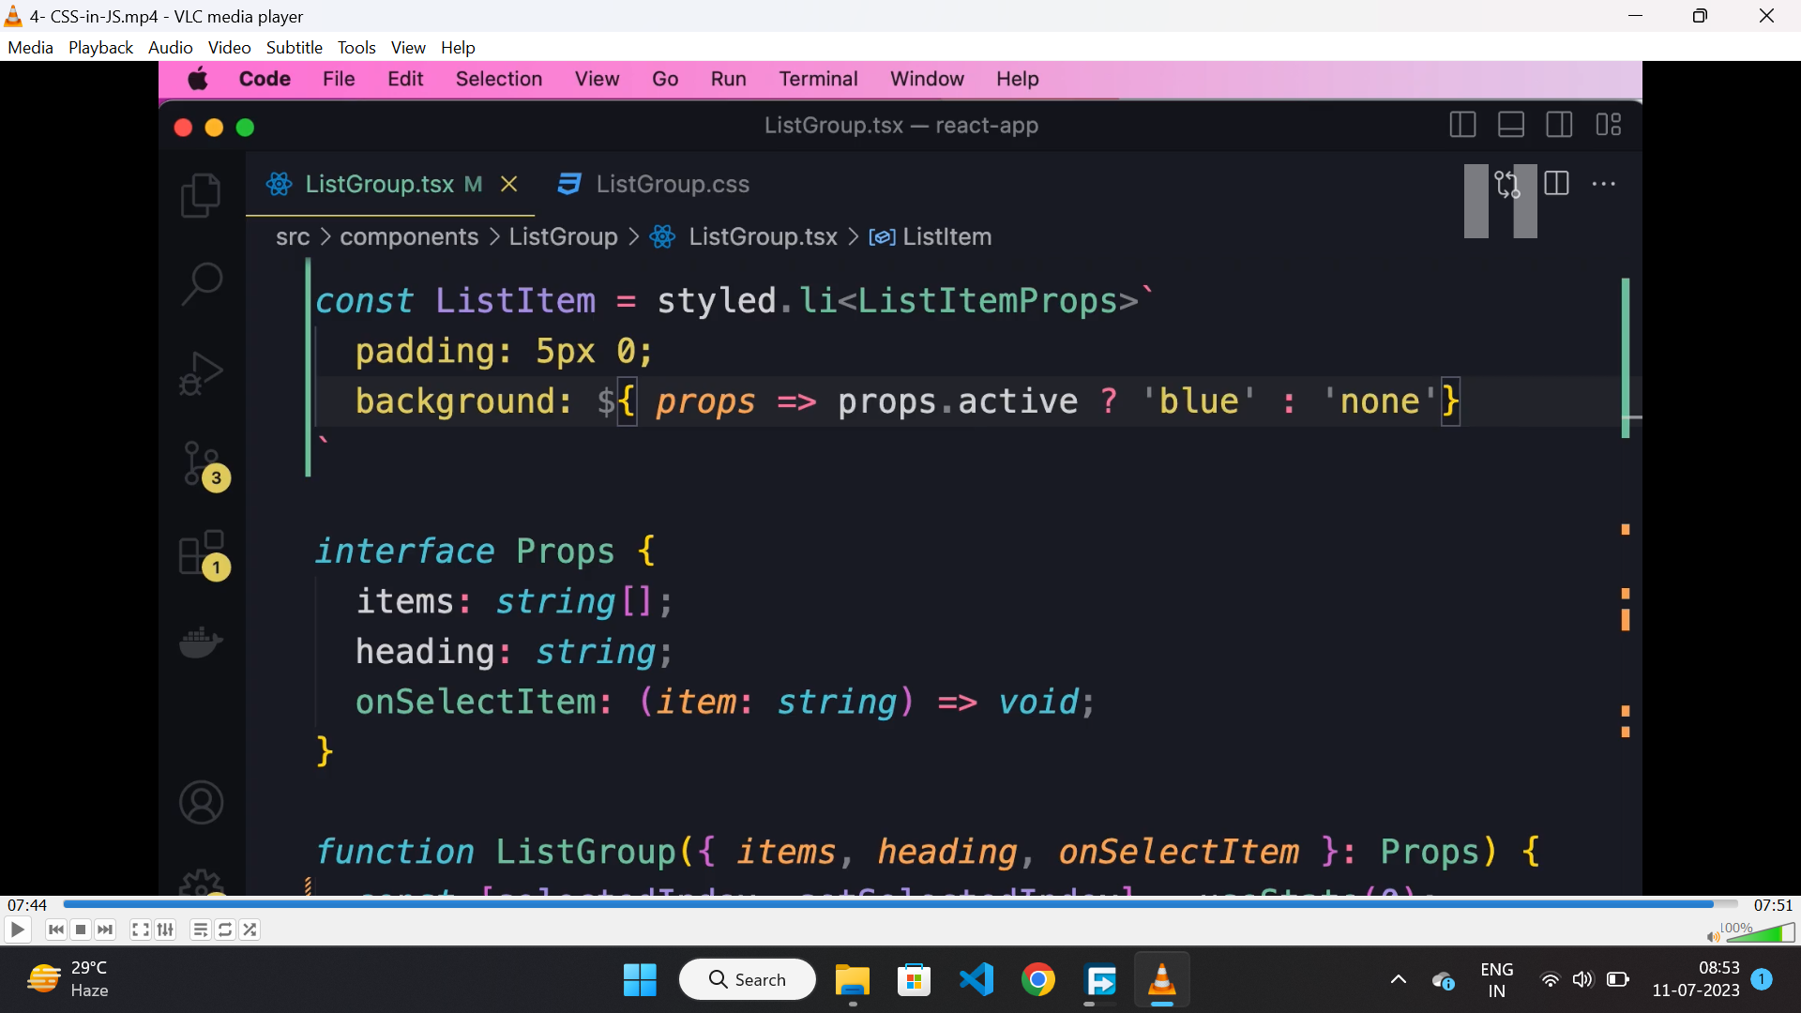

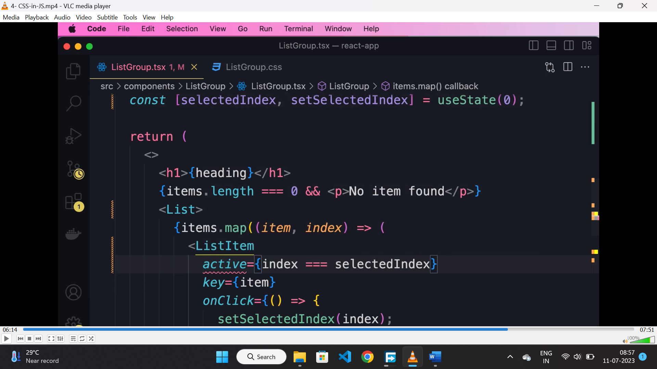

* It is a object which has all the html tags, using backtick we can define style for that HTML element and it will return a react component.
* We can also pass props to styled component.

**Inline style:**

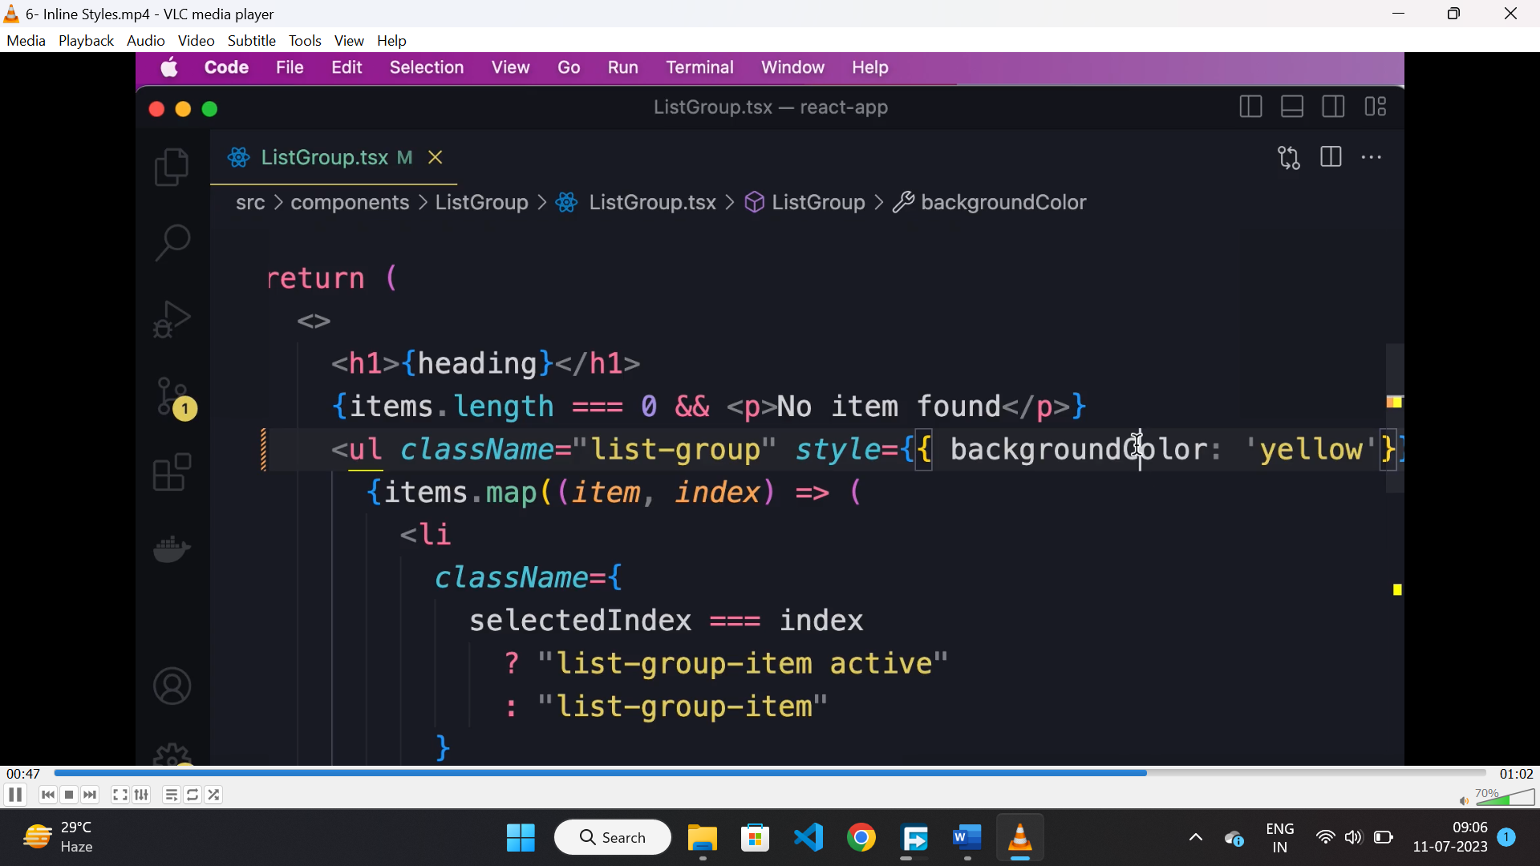

* We can apply inline style using the “style” attribute.
* The css properties should be mentioned in camel case notation here.

**React state:**

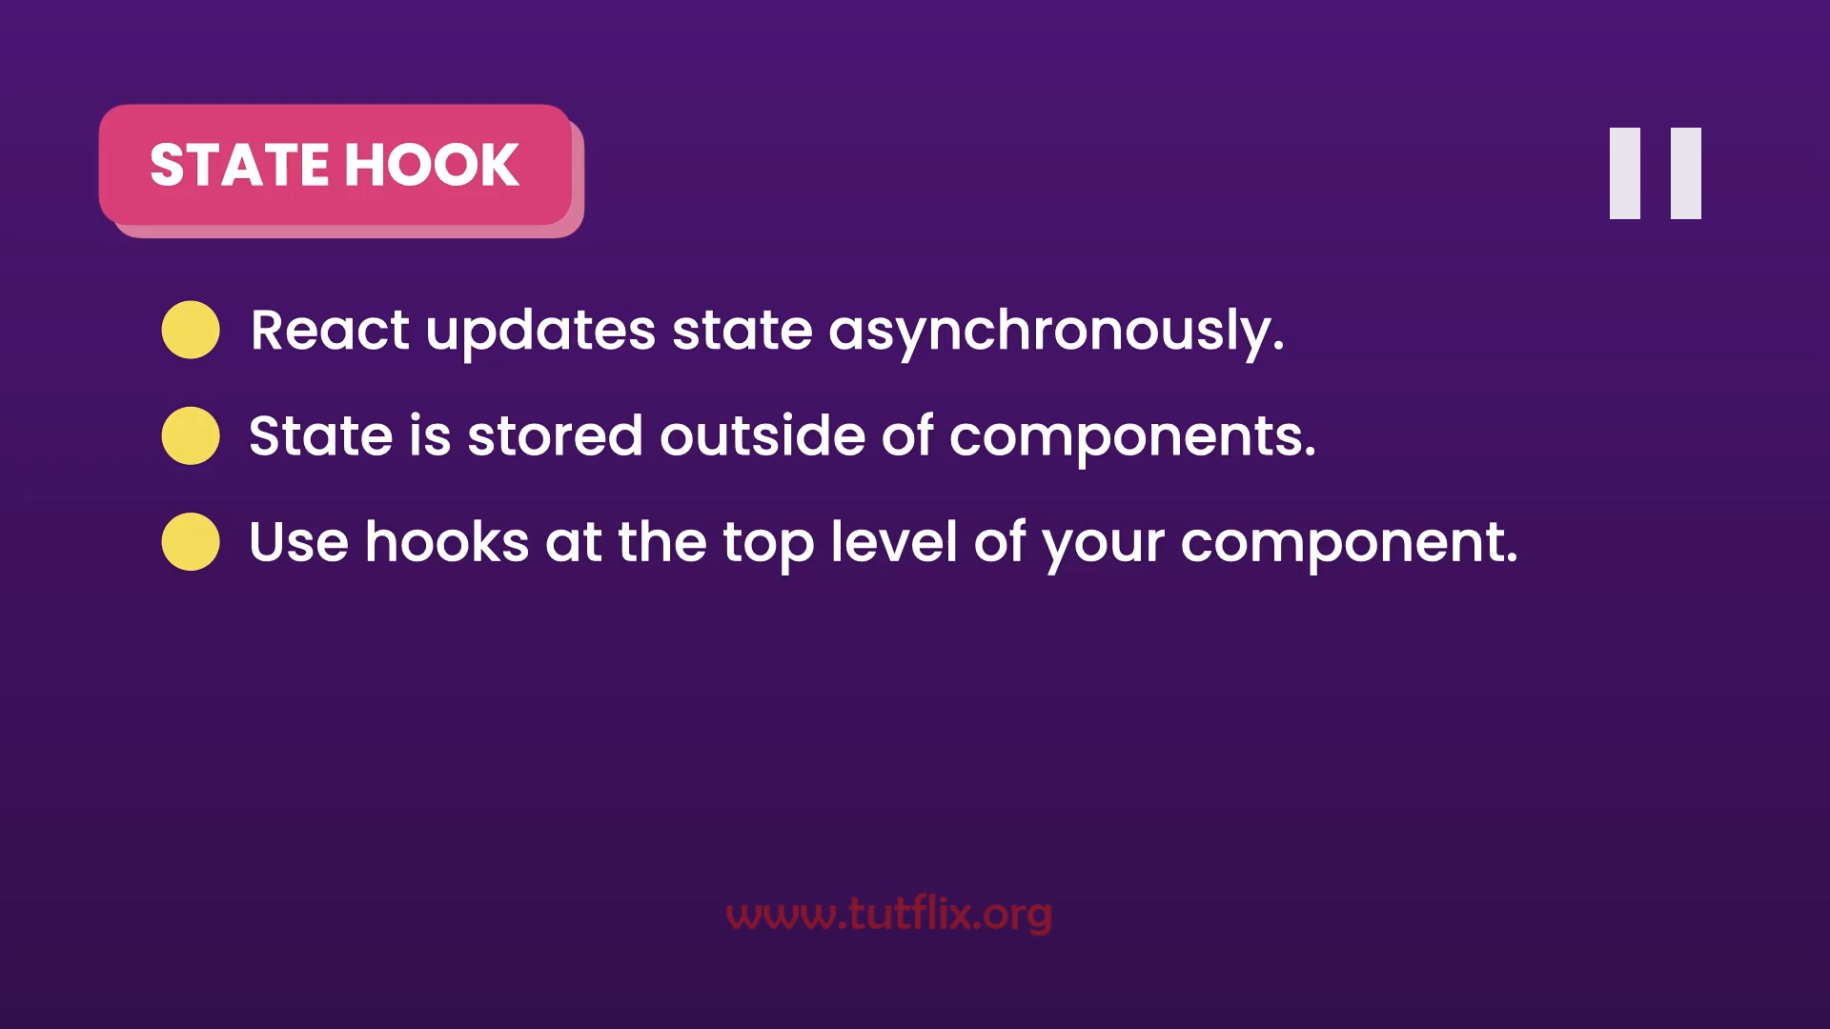

**Pure component:**

* If a component renders the same output for the same state and props then it is a pure function.
* React uses pure function for performance optimization, means if the props of the component didn’t change then it will avoid unnecessary rerenders.

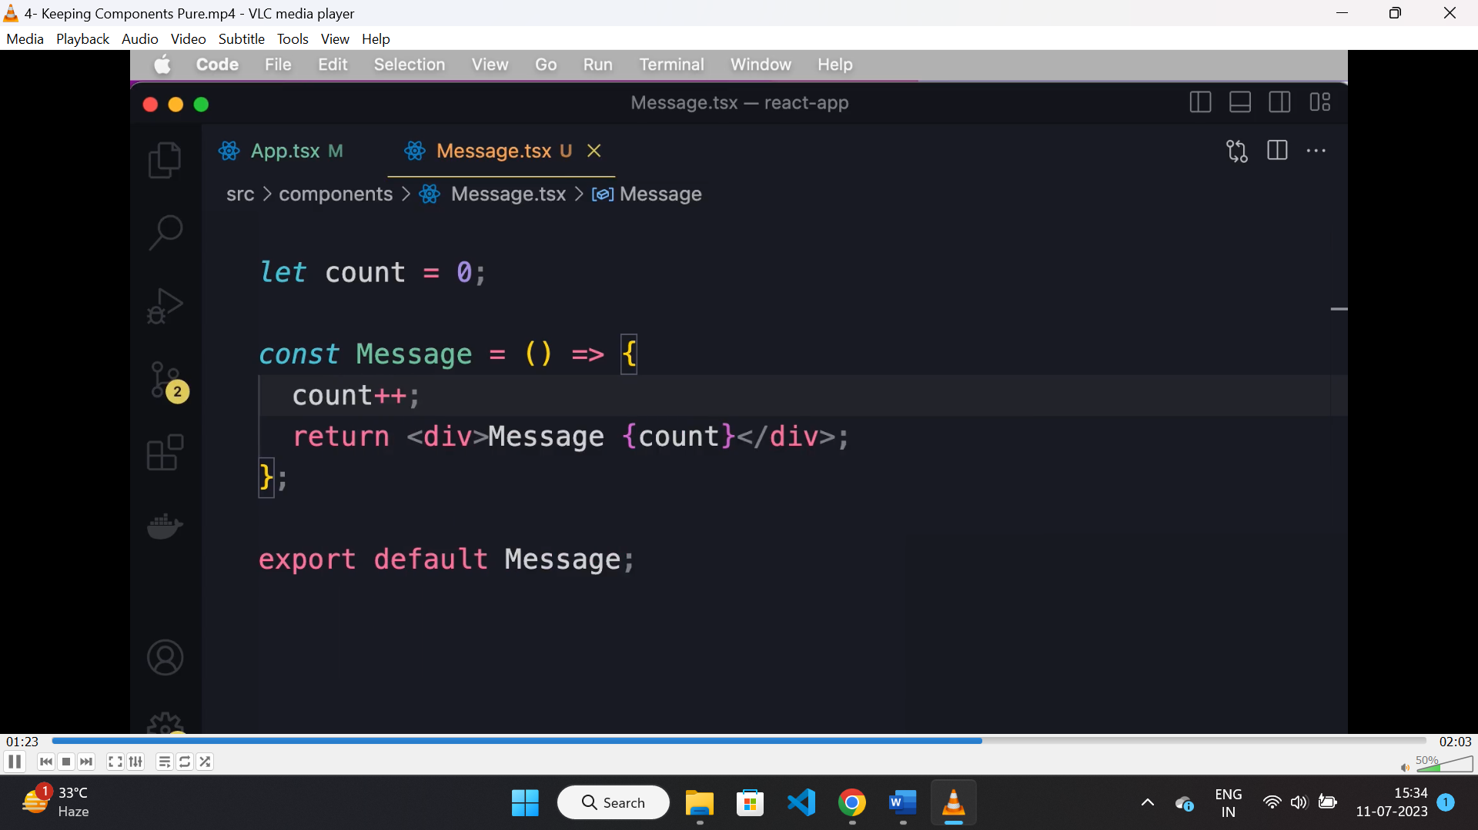

* Above is the example of “impure” function, coz the value of count changes on every render of this component.

**Useref:**

* It is used for referencing a DOM element and read its value when form is submitted.
* “useRef” returns a reference object.

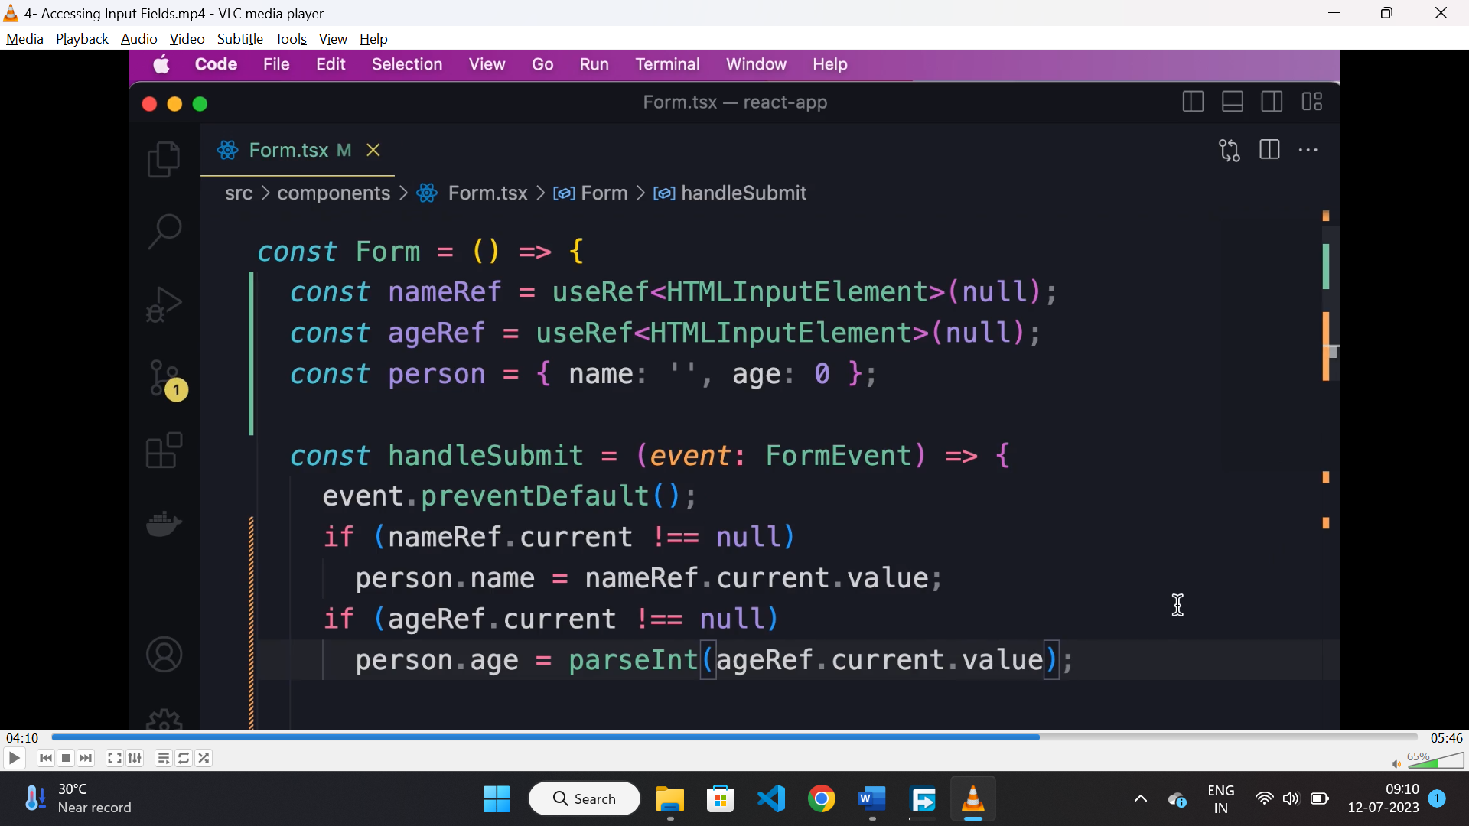

**Controlled component:**

* If the value of the html element is entirely controlled by state and not by DOM then it is a controlled component.

**React hook form:**

* It is a library that helps to manage complex form in ease, it is lightweight and high performance.
* To use it we need to import useform hook and destructure register and handlesubmit out of it.
* Handlesubmit will be called when form is submitted.

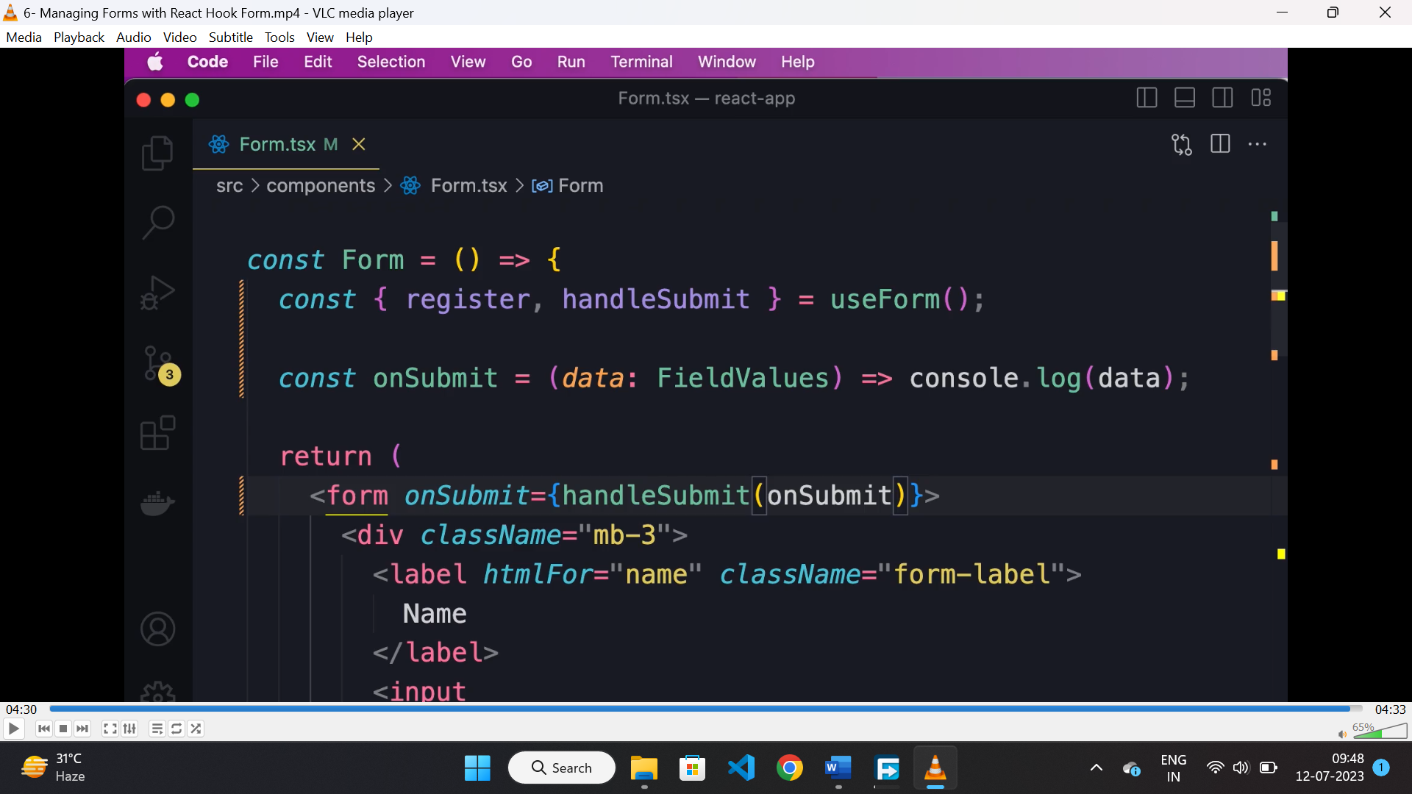

* To register a html element, we need to call the register function passing the name of the field as parameter and it returns an object.

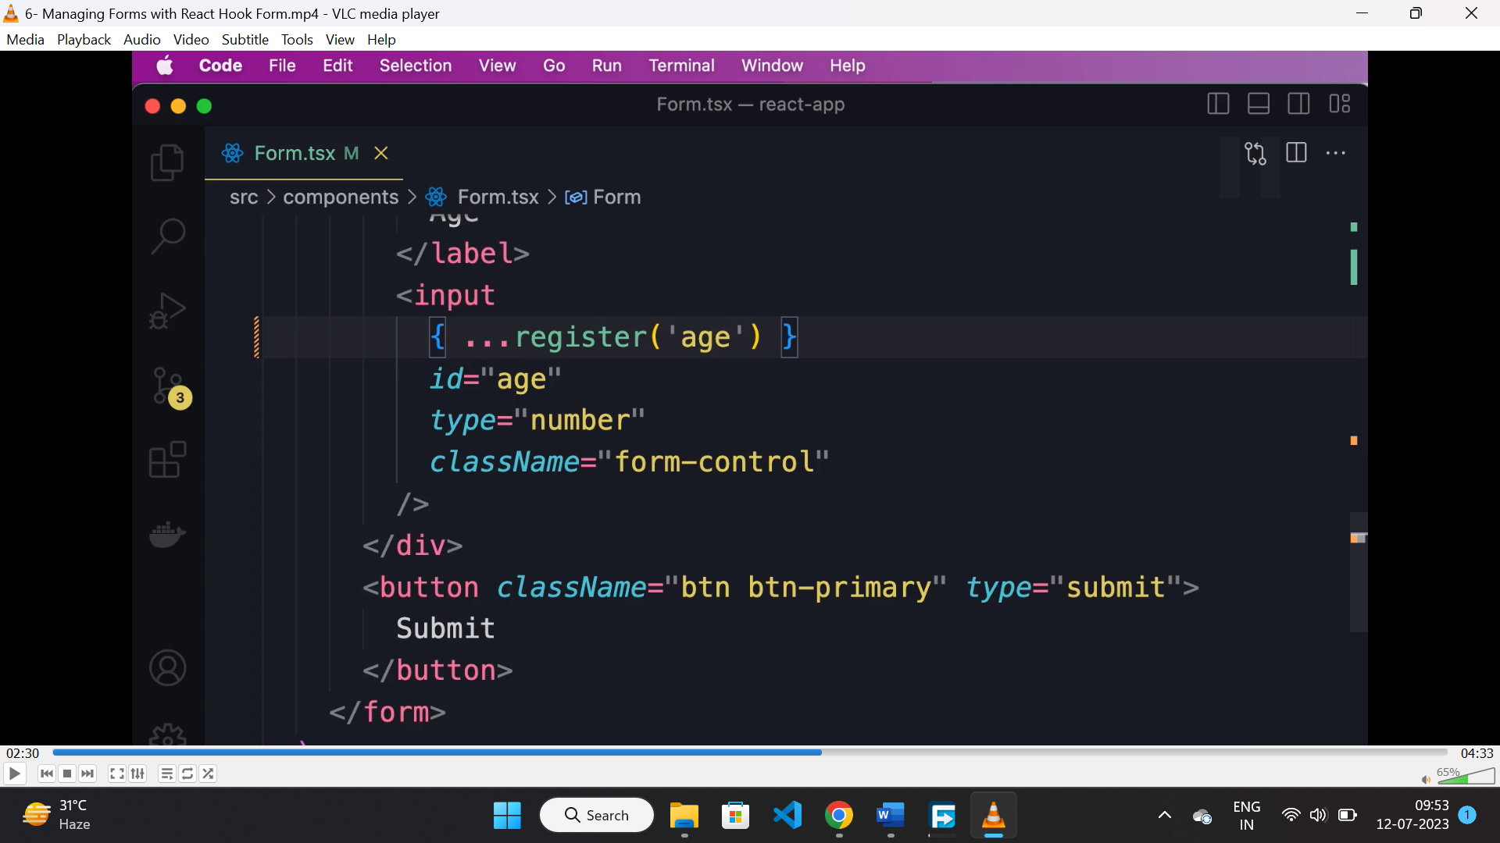

* By registering a element following property will be added to the HTML element.

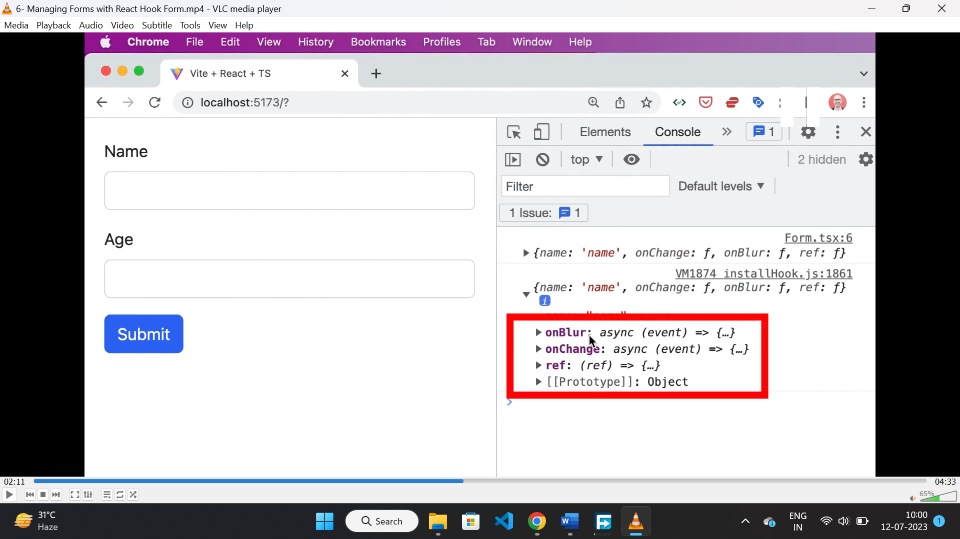

**Handling validation using form hook:**

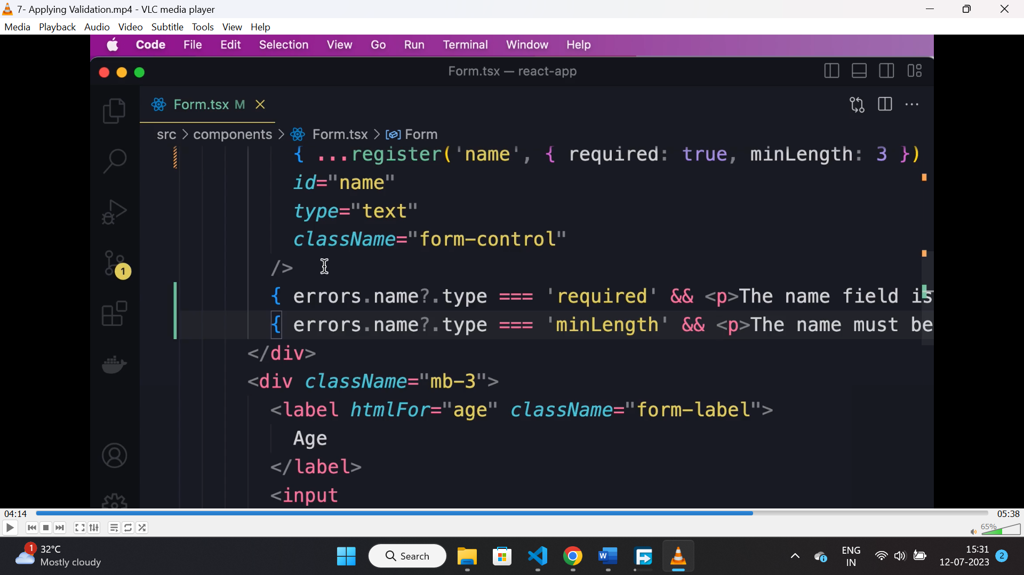

* Here in register function, we can pass a second parameter as a validation object. The properties are “required”, “min-length” and “max-length” etc.
* If the filed is failed to validate then, while submitting the form the “useForm” will kick in and we can destructre the formState from there and check for error form there.

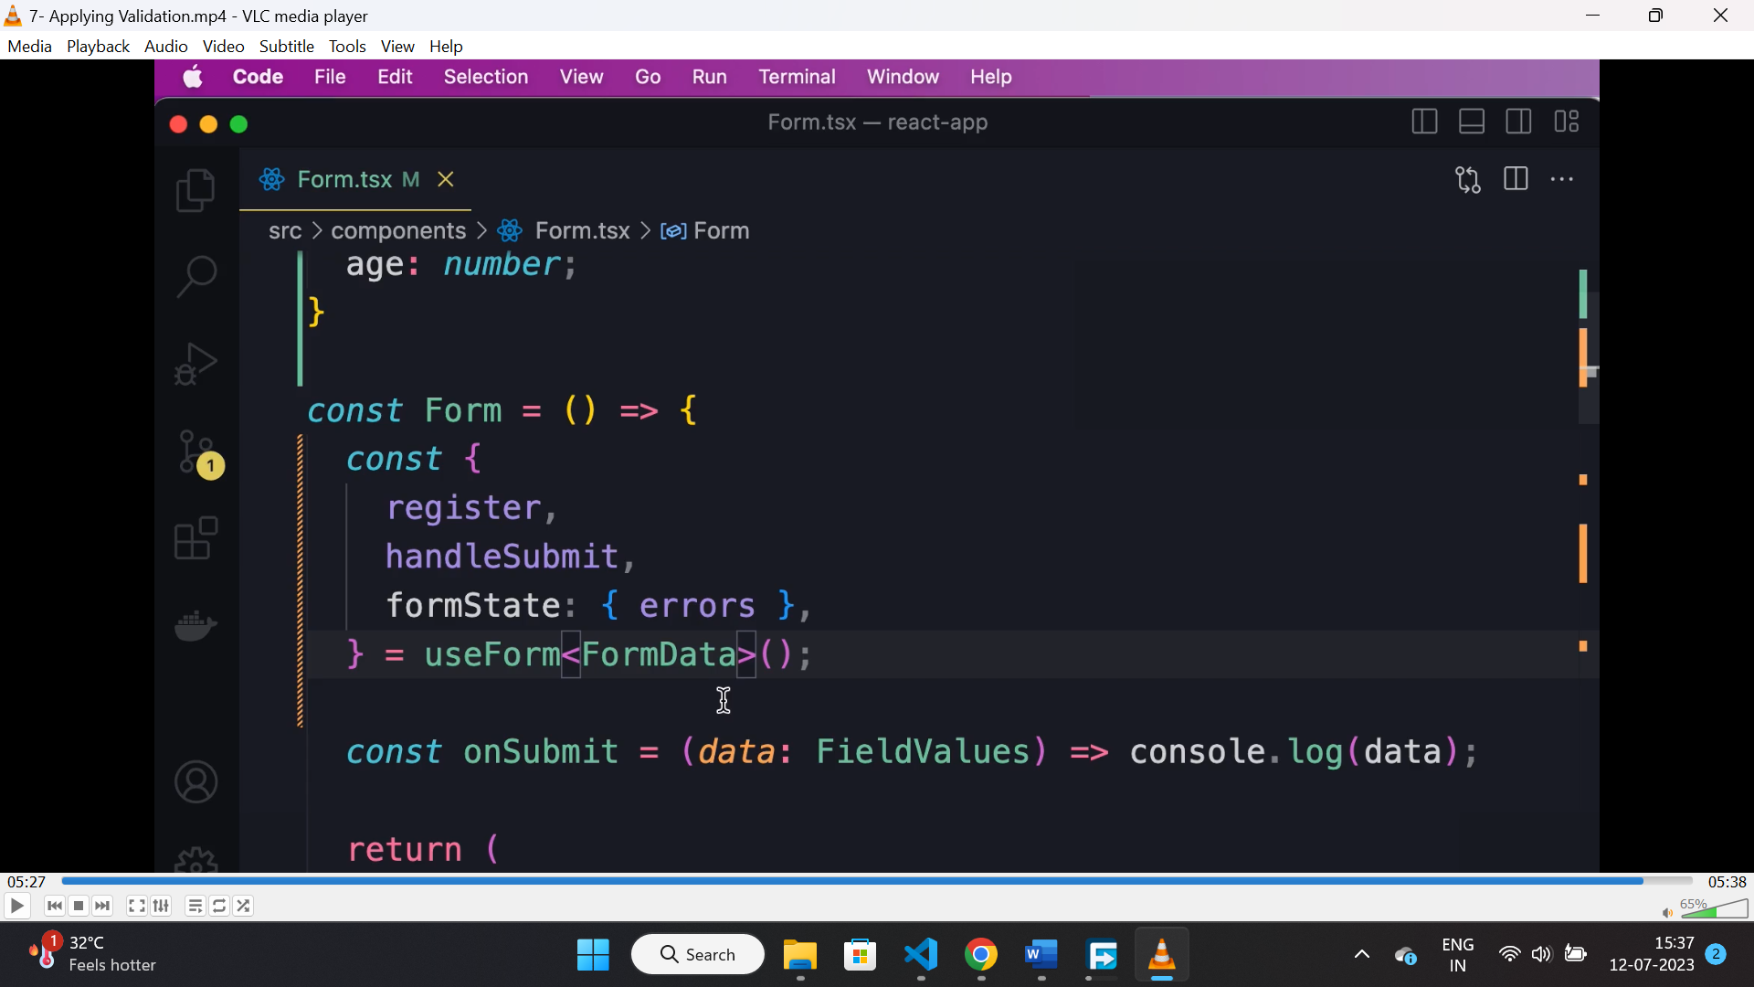

* Based on the validation error we can render errors below the filed.

**Validation with ZOD:**

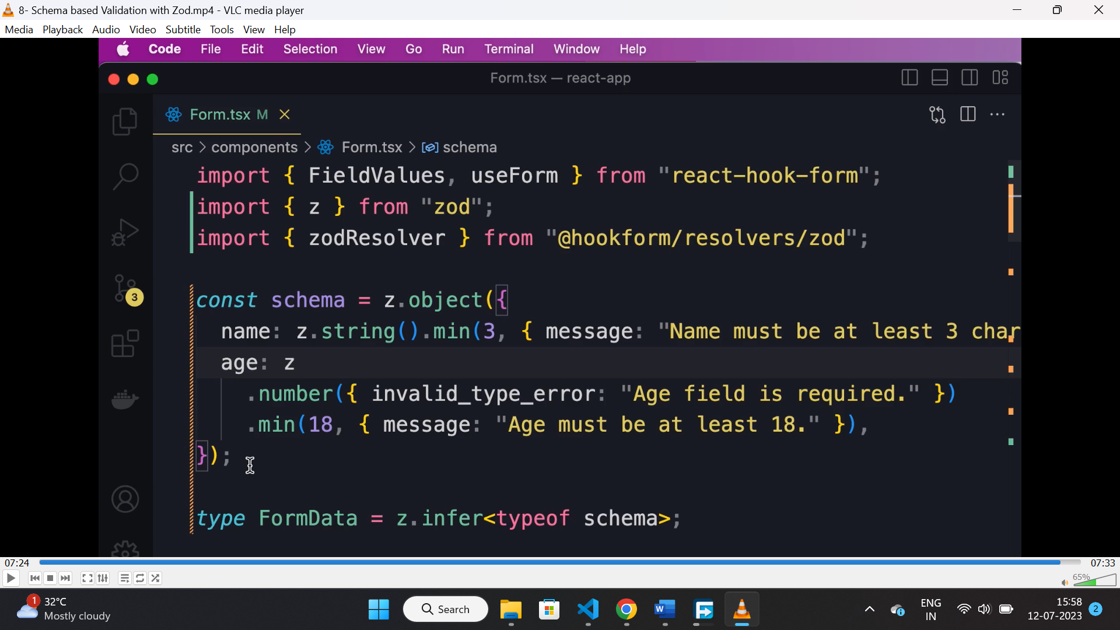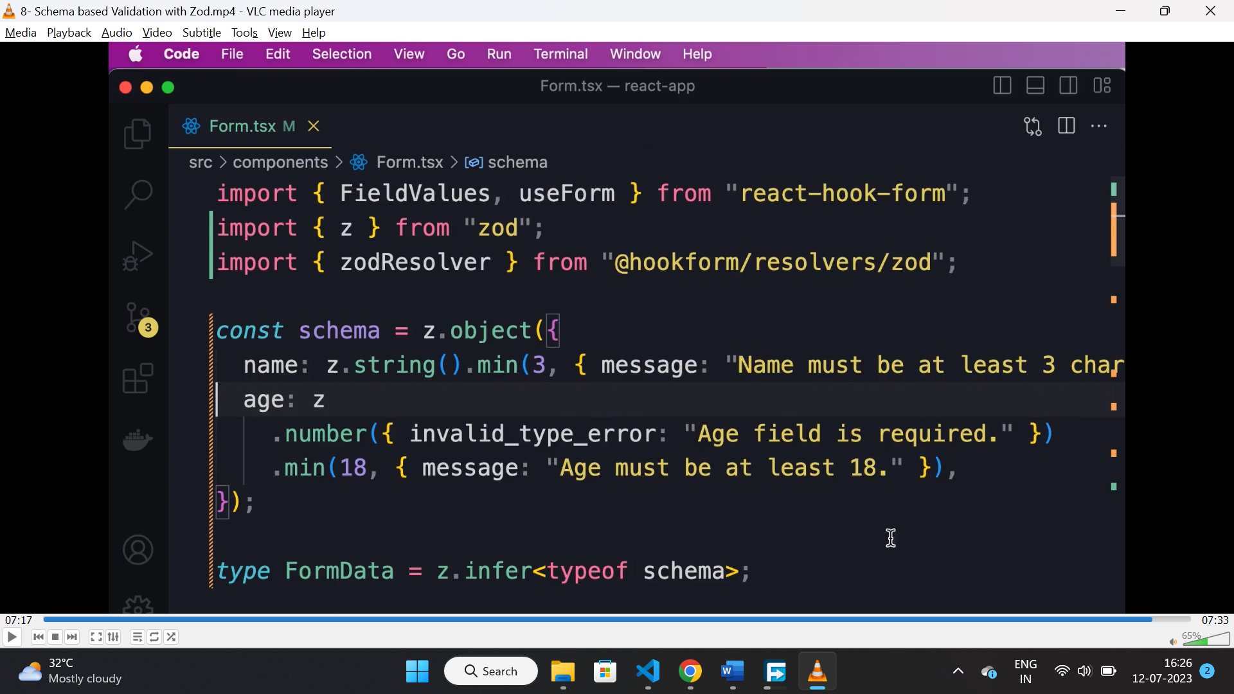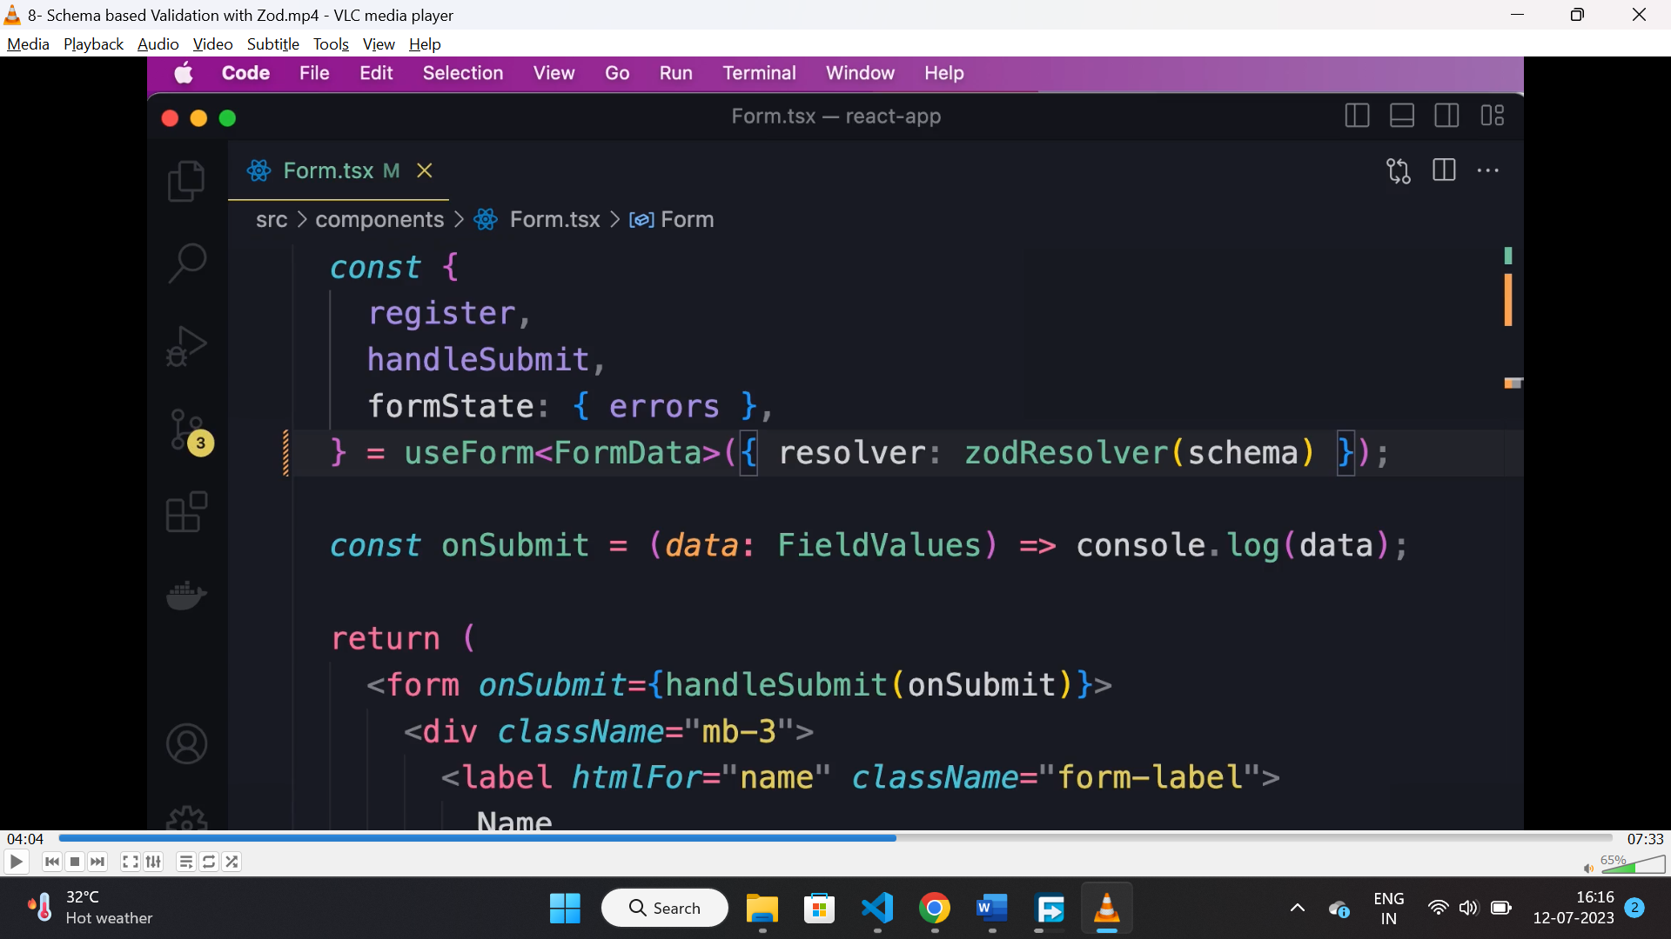

* Create a schema object using zod.
* Install “@hookform/resolver” for integrating zod with “hookform”.
* Pass “zodResolver” function as a resolver, with created schema as a parameter to it.
* While creating schema we can create custom error messages to it.

**useEffect hook:**

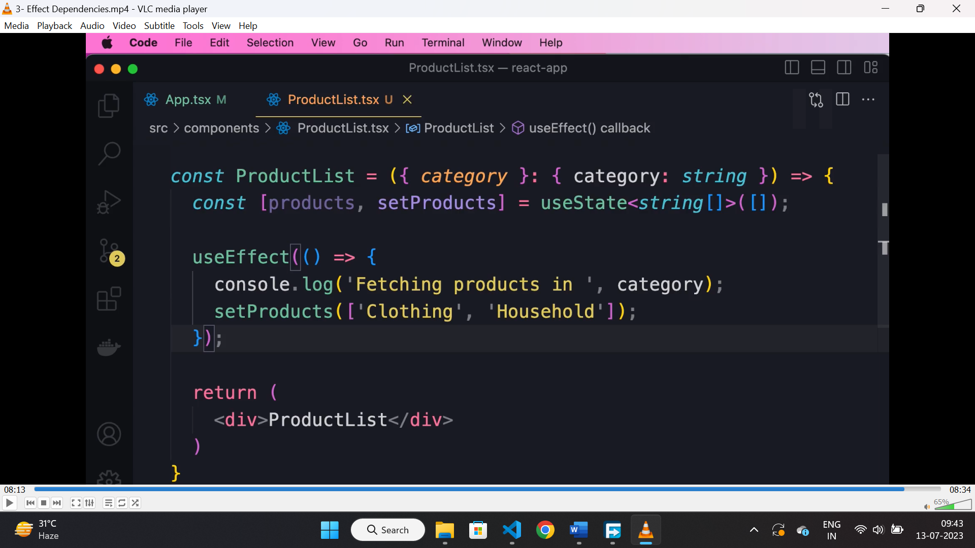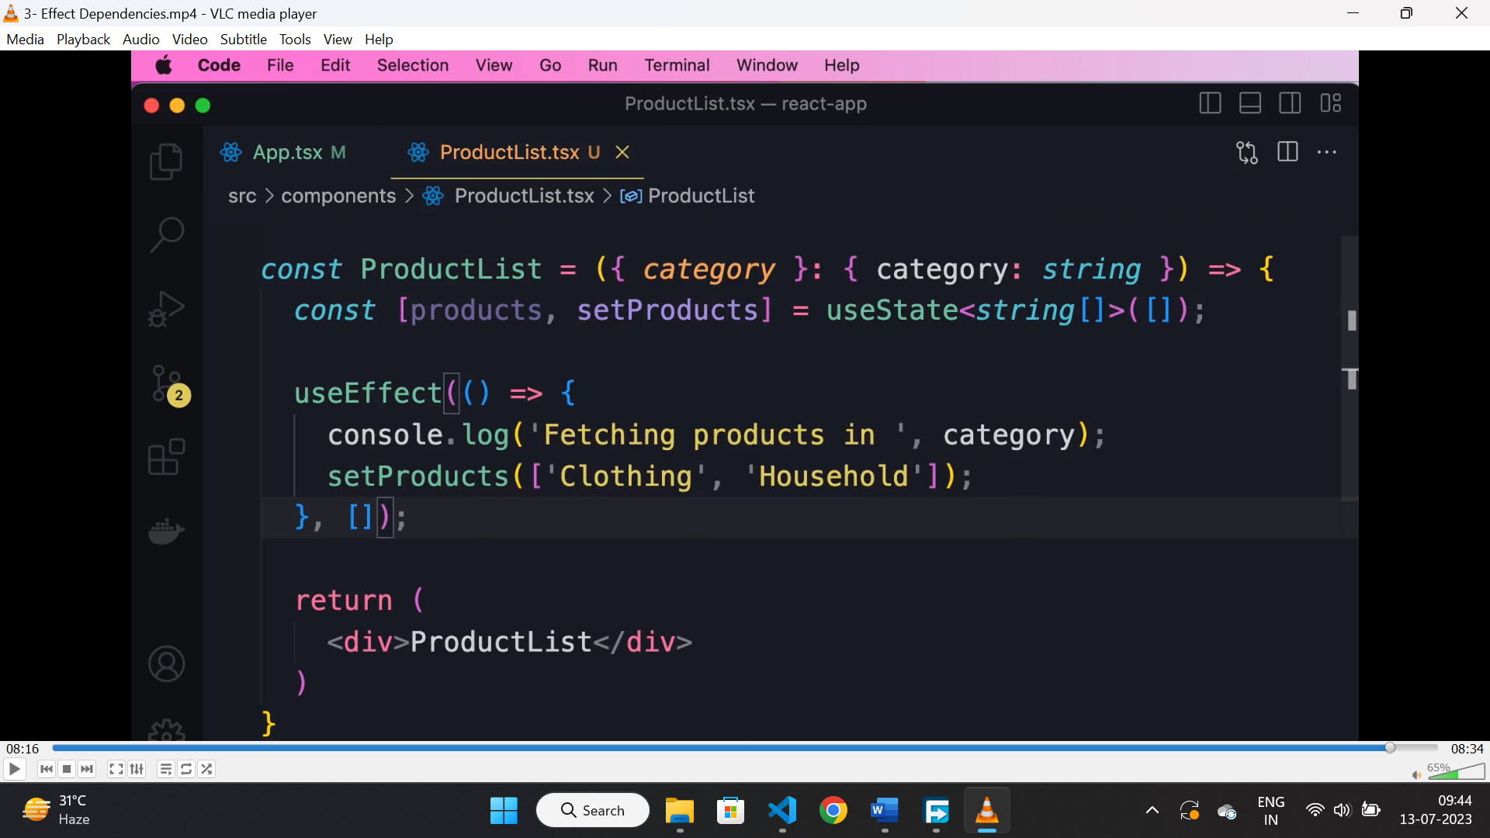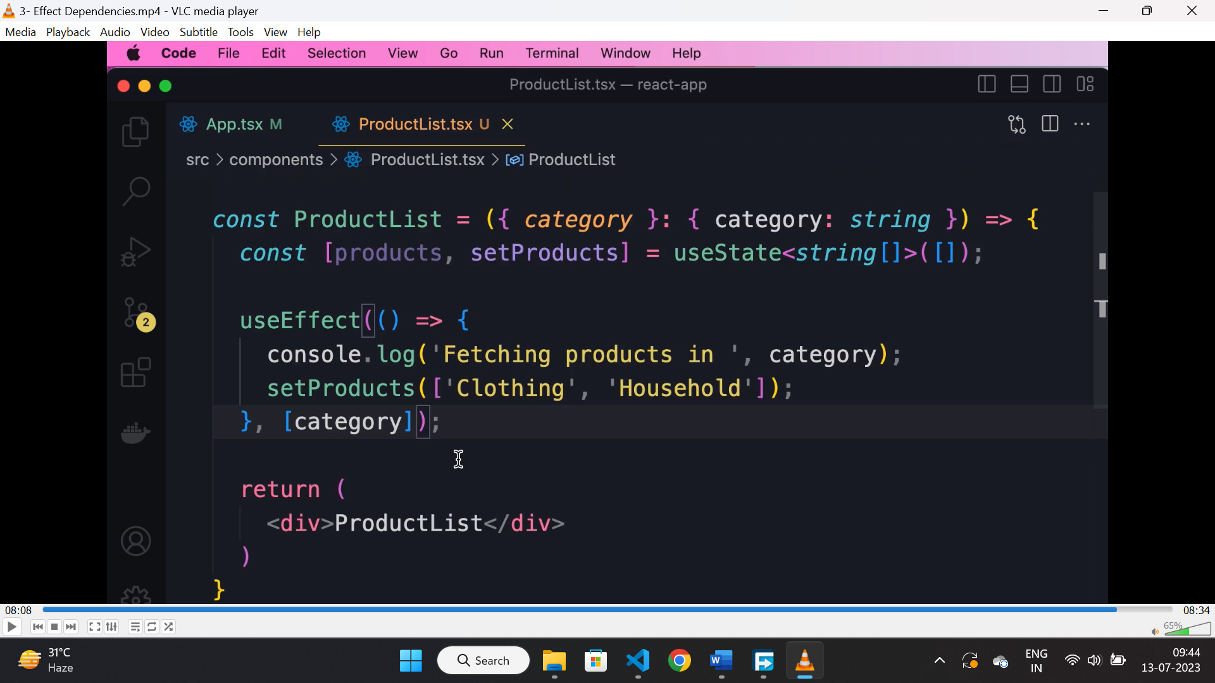

* If we are not passing any 2nd argument then “useEffect()” hook will run in first and on every render on state or props change.
* If we pass 2nd argument as empty array then it will run on 1st or initial render only.
* If we pass any value in 2nd parameter then “useEffect()” will run when there is a change in the dependency.

**useEffect as unmounting:**

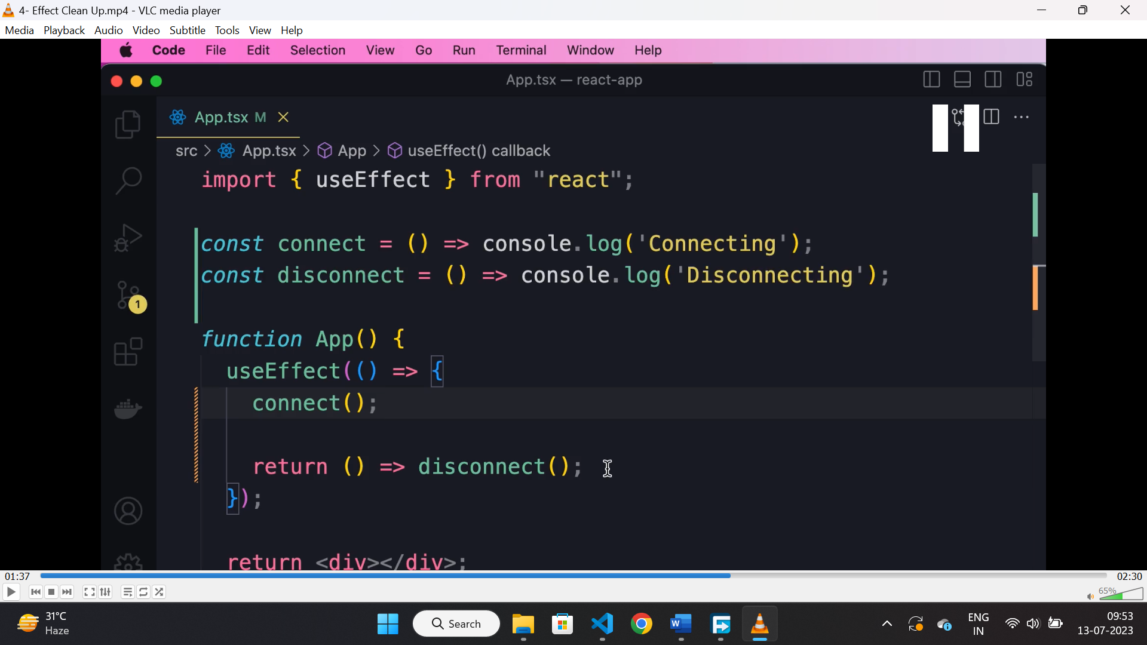

* “useEffect()” optionally returns a function which is used for cleanup.
* It is used for cancelling API calls, ignoring results from API, disconnection to server etc.

**Handling error with Async await:**

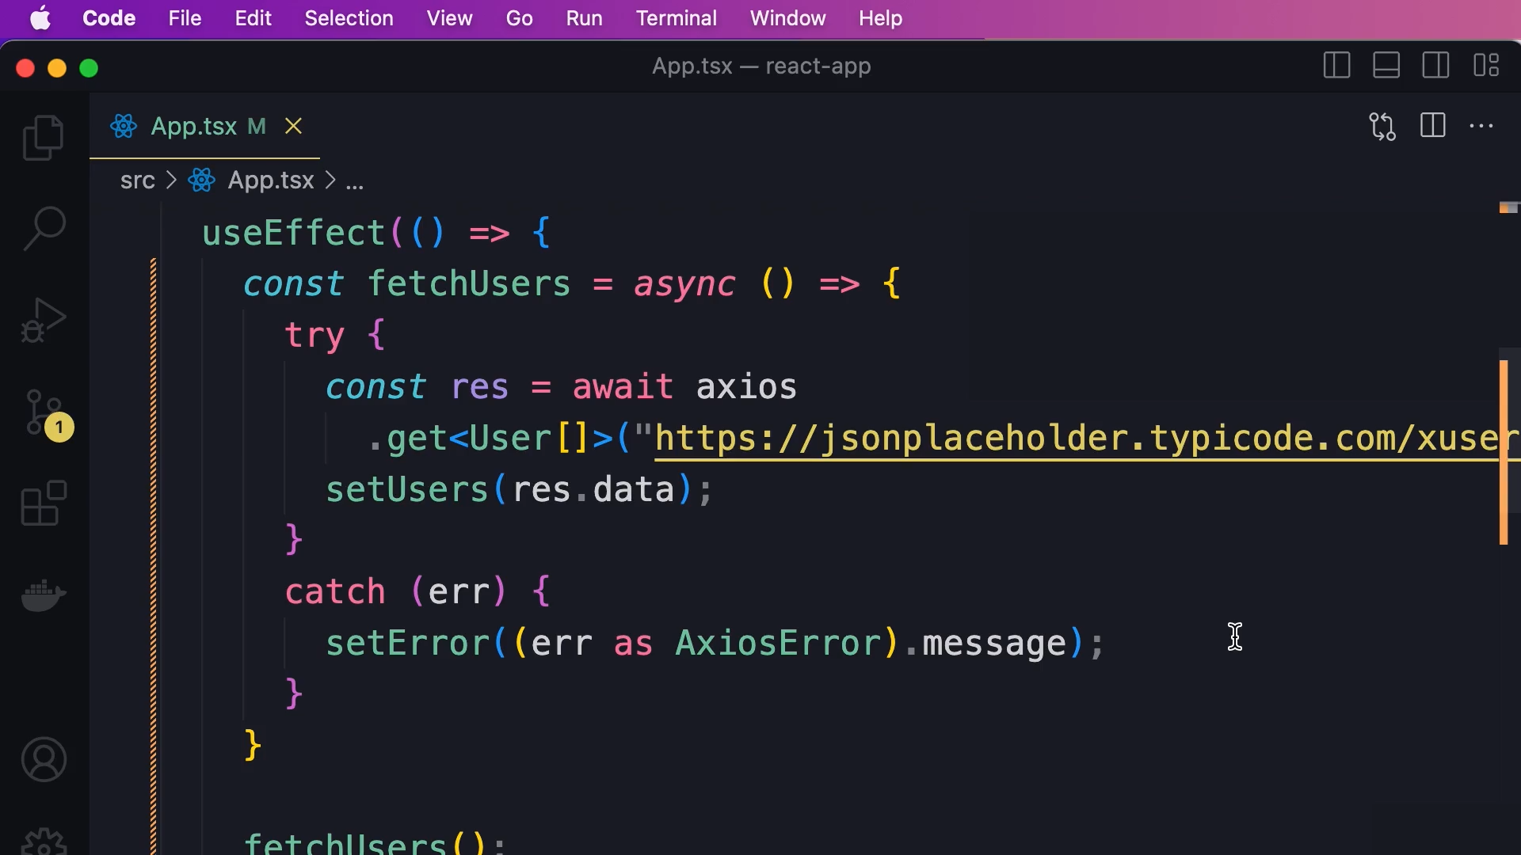

* With traditional promise method we can use “.then().catch()” method to handle data and error.
* With async and await we can use “try{}catch(err){}” for handling error.
* Traditional method is preferable.

**Cancelling a API call:**

* To cancel asynchronous operation, DOM manipulation or task that will take time, we can use “AbortController()” class.
* Then we can pass a second parameter to “axios.get()” set “signal” property of “controller.signal” there.
* Finally in the cleanup function we can call the abort() method of controller instance.

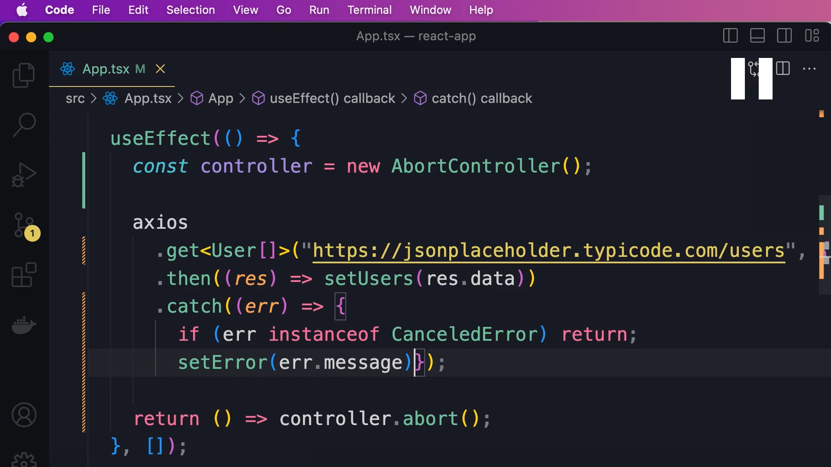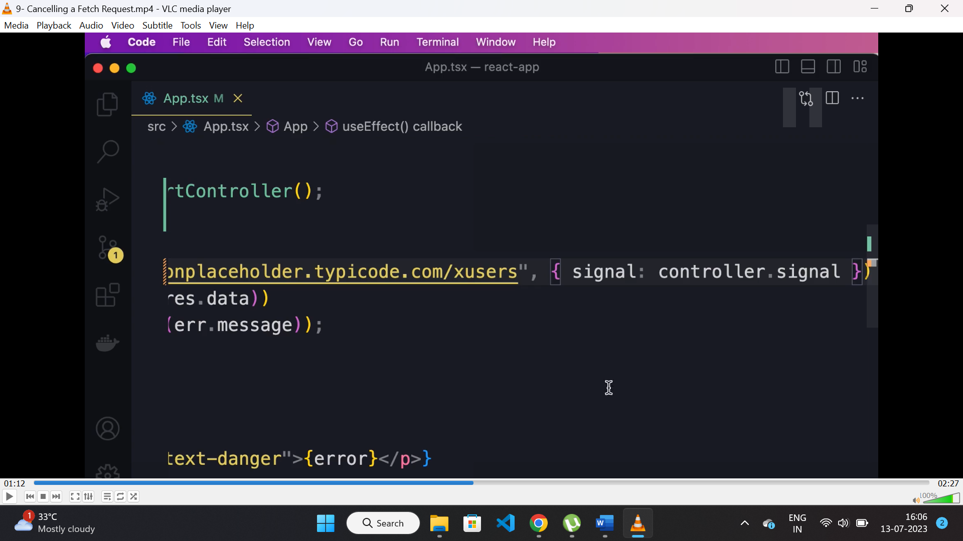

**Axios:**

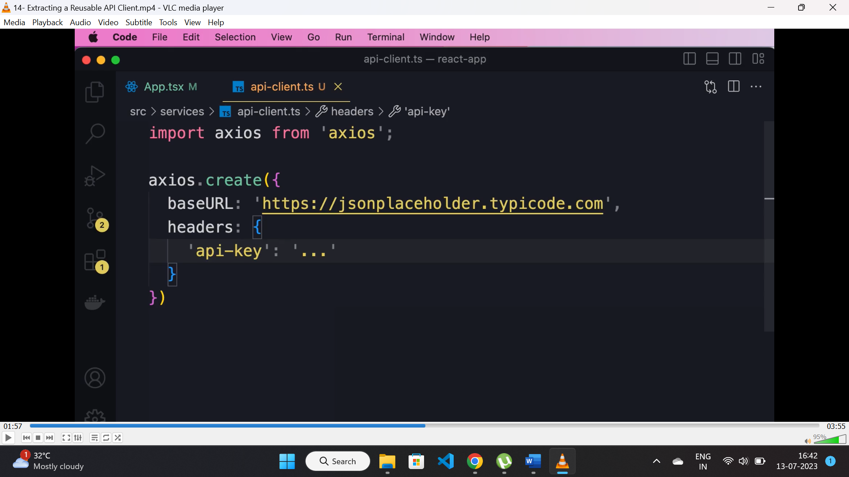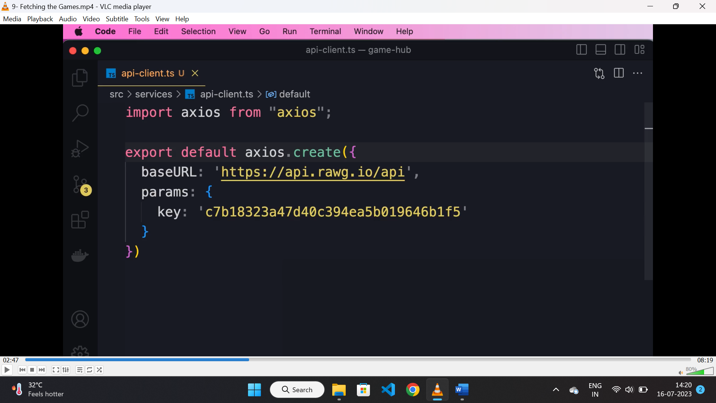

* To create a reusable API client “axios” provides configuration for adding “baseURL” and “header” to be set before being used.

**Extracting service:**

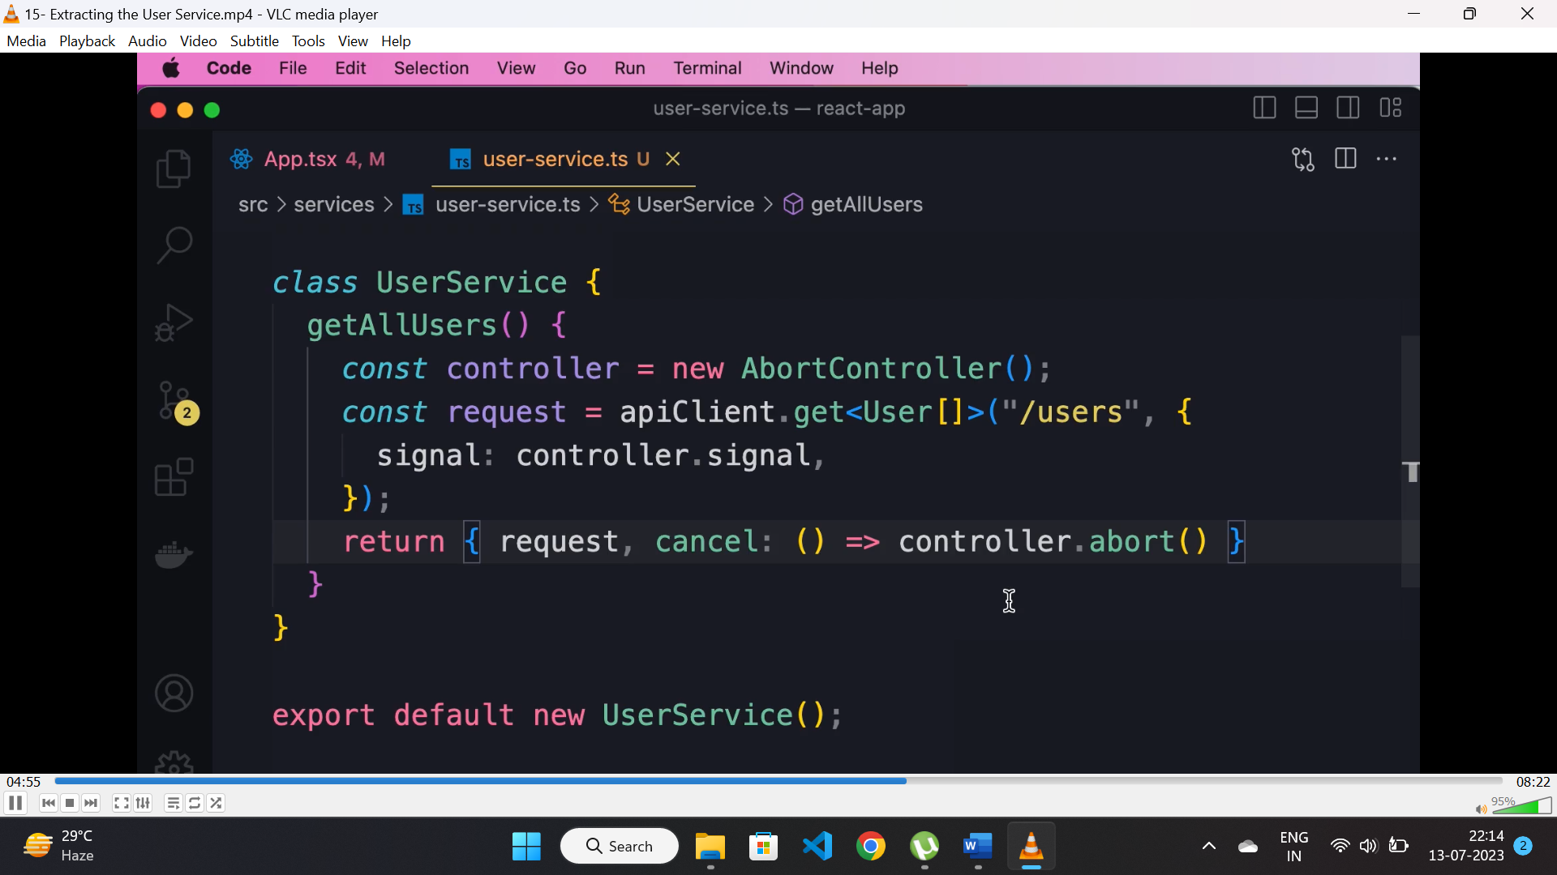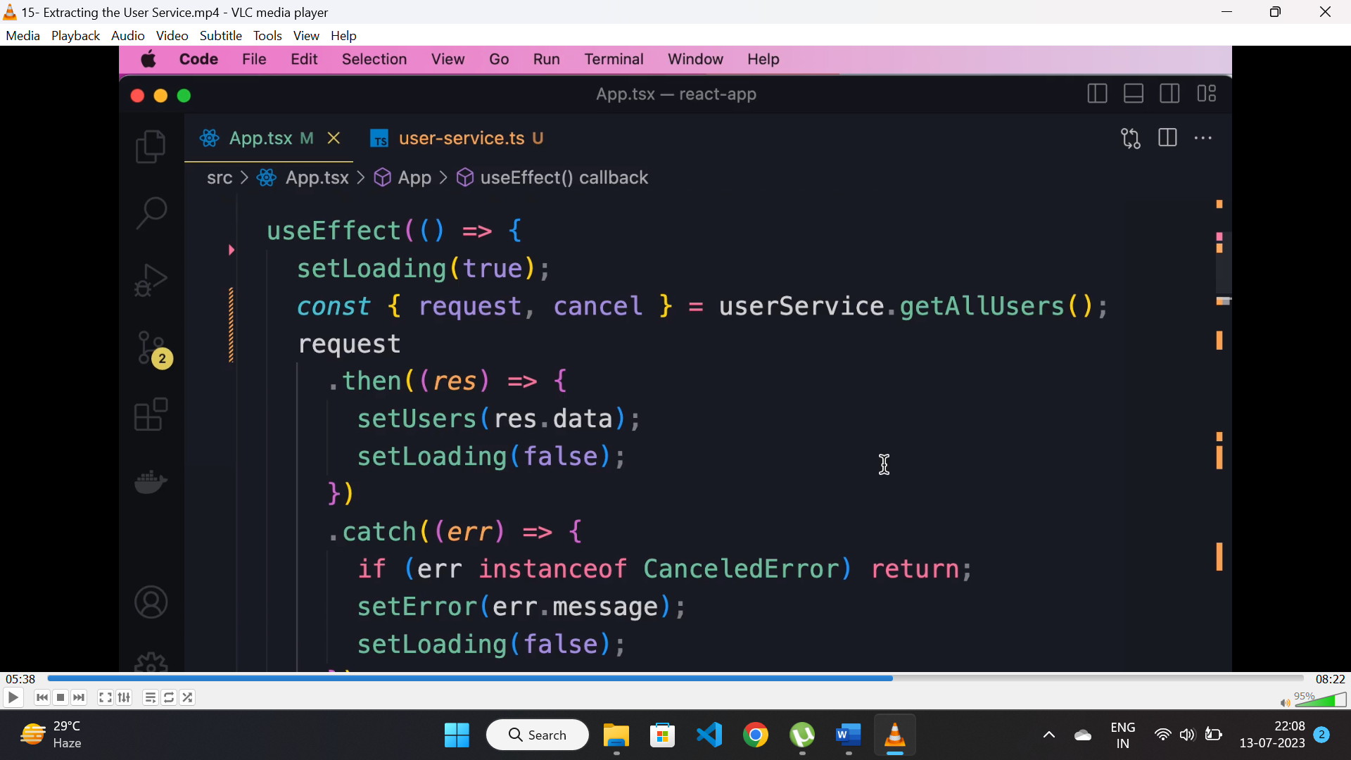

* Instead of calling APIs directly from “useEffect()” hook, we can create a service class for calling APIs and call them whenever it is required to call APIs.

**Generic http service:**

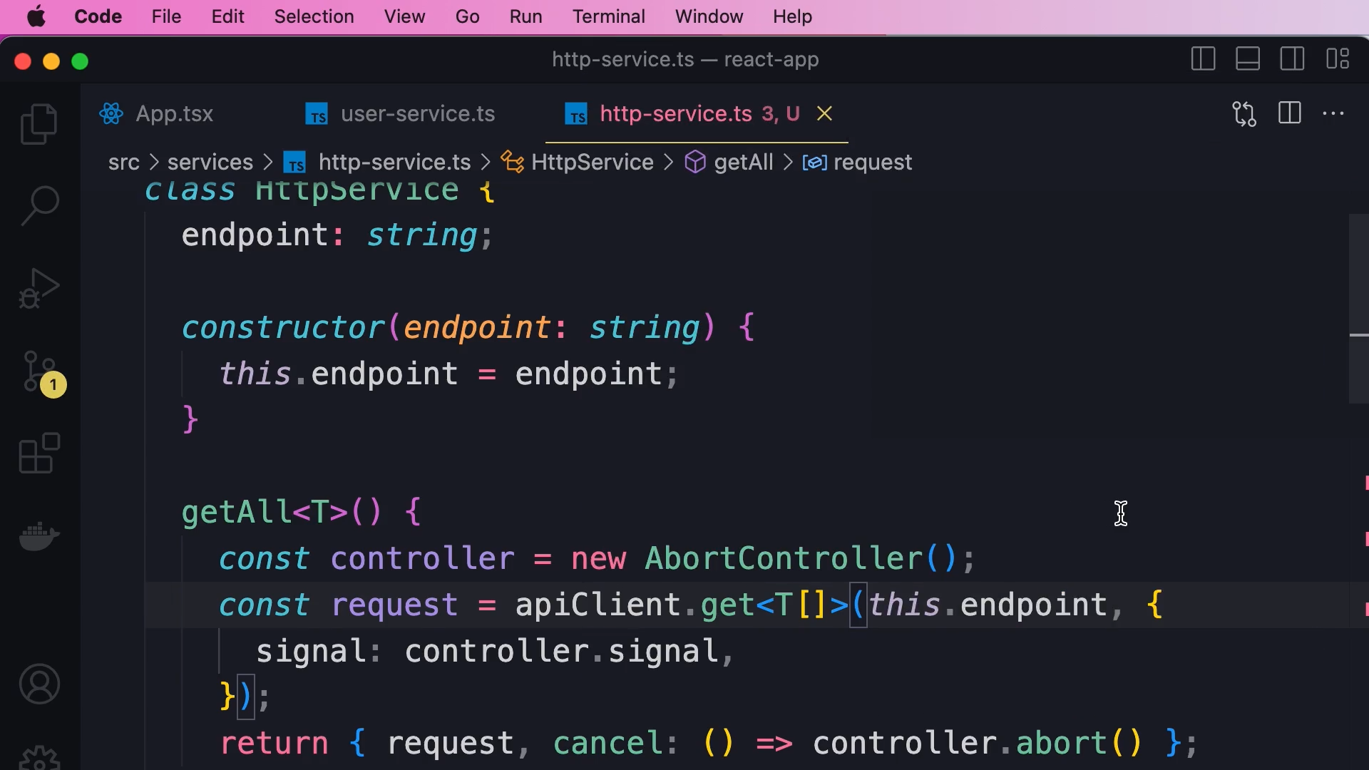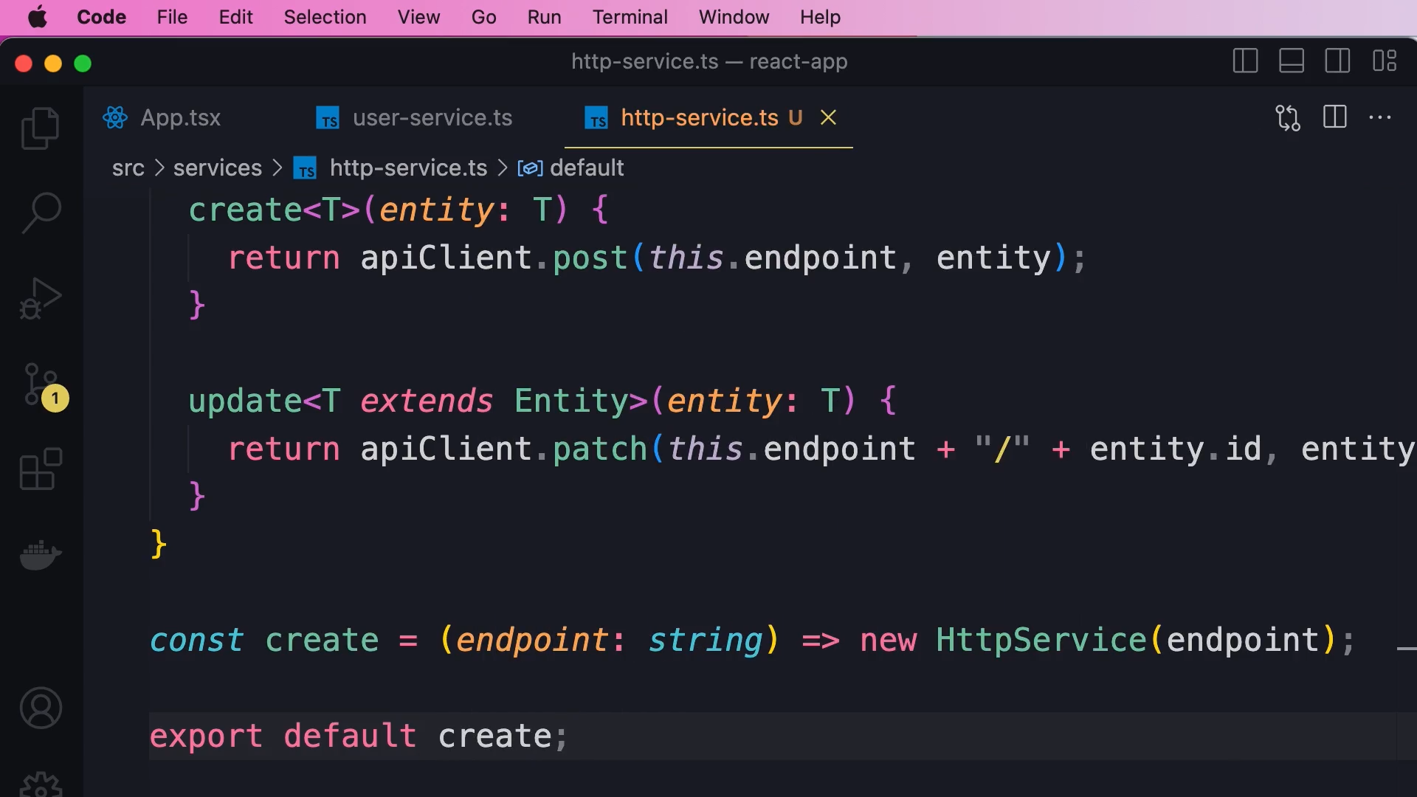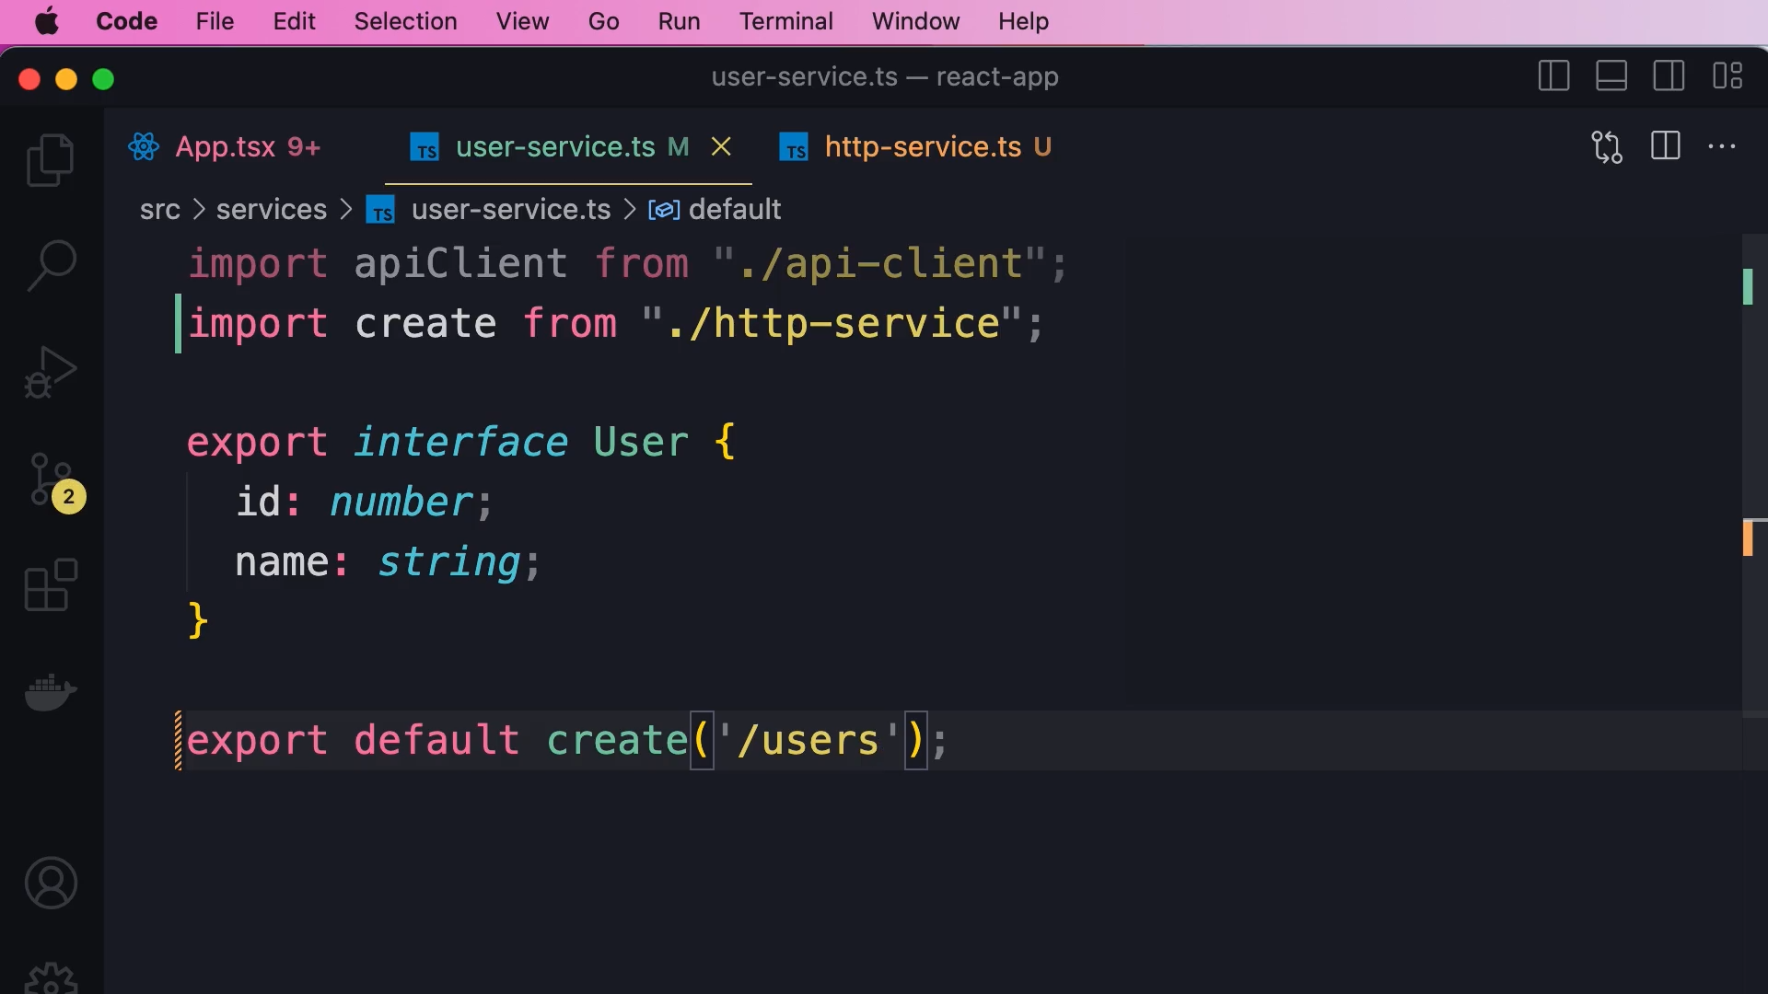

* Instead of calling APIs(services) inside “useEffect()” or any other middleware, we can create a generic service class and define CRUD operations methods inside it.
* Create a constructor for routes.
* Initialize the object of that class with the required route and use its methods.

**Customhook:**

* A “Customhook” is a simple function which we can use for sharing functionalities.
* If we can have repeating code in multiple component, then we can use a “customhook” and add the repeating code within that and use that hook where ever required.

**React query:**

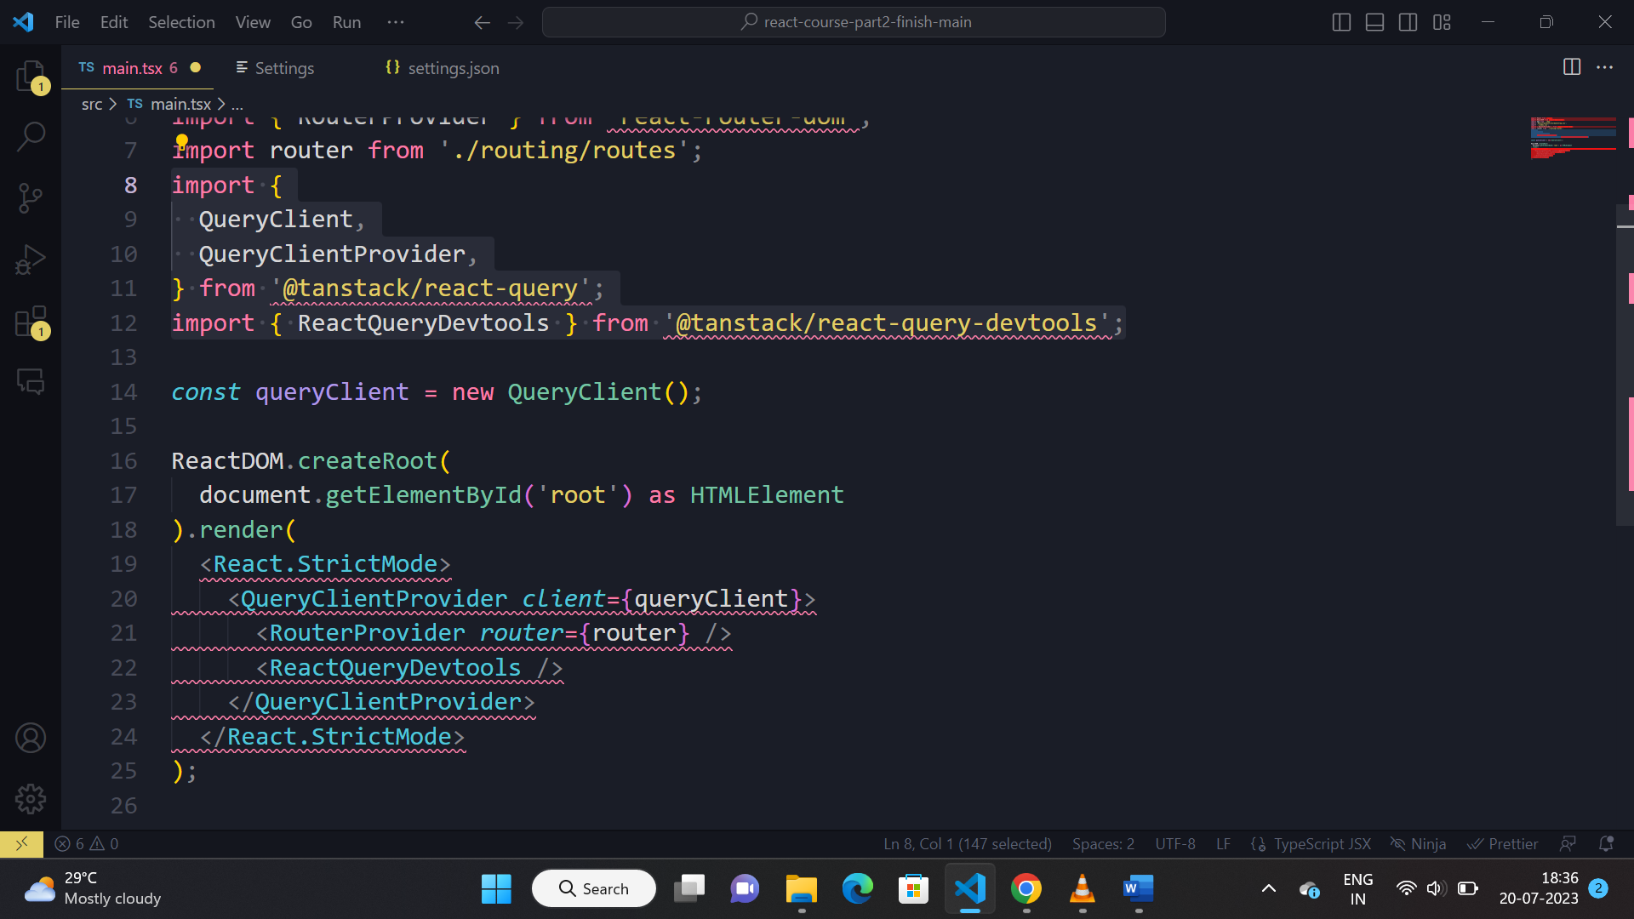

* To use react query in application 1st we need to pass “queryClient” object throughout the application using “QueryClientProvider” component.

**Fetching data using RTK:**

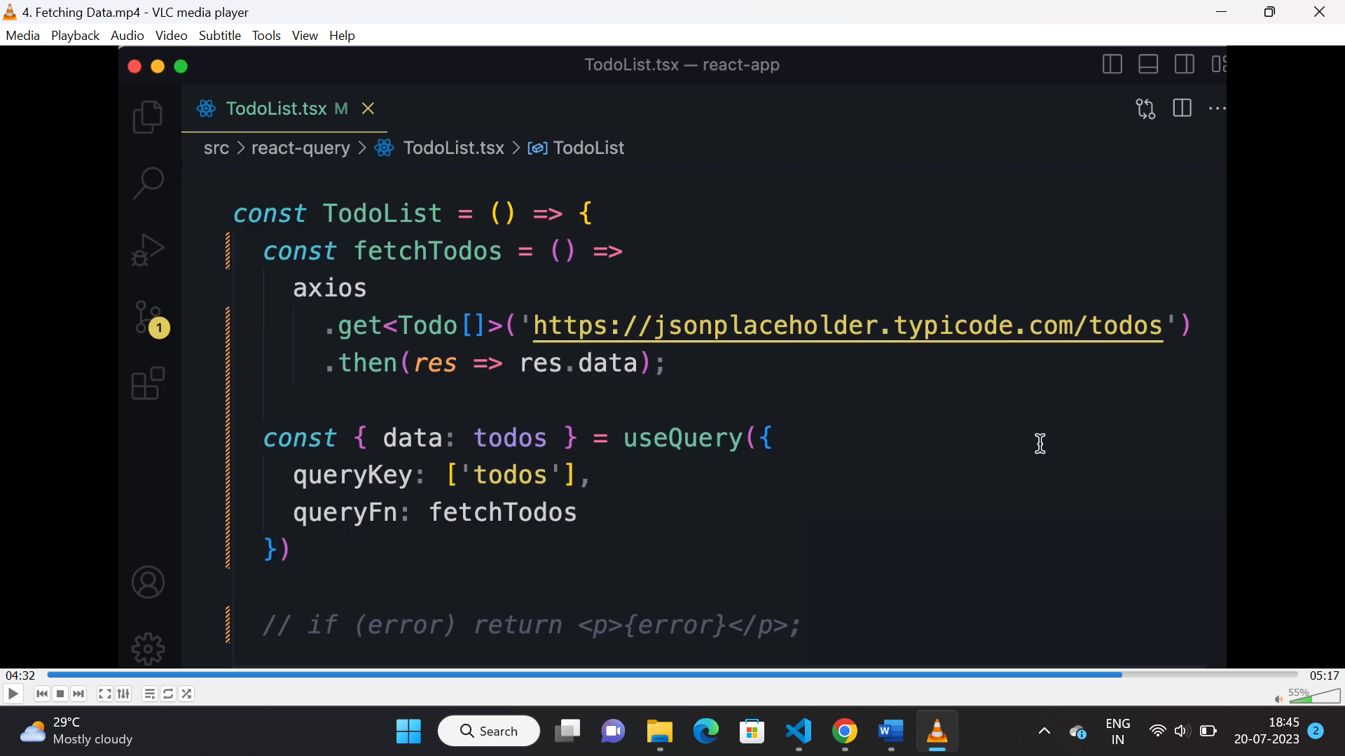

* “useQuery” is used to fetch data from database.
* It returns {data, error, isLoading}.
* “queryKey” is used for store the fetched data in cache.
* “queryFn” is used to call the API service.

**Configure queryClint:**

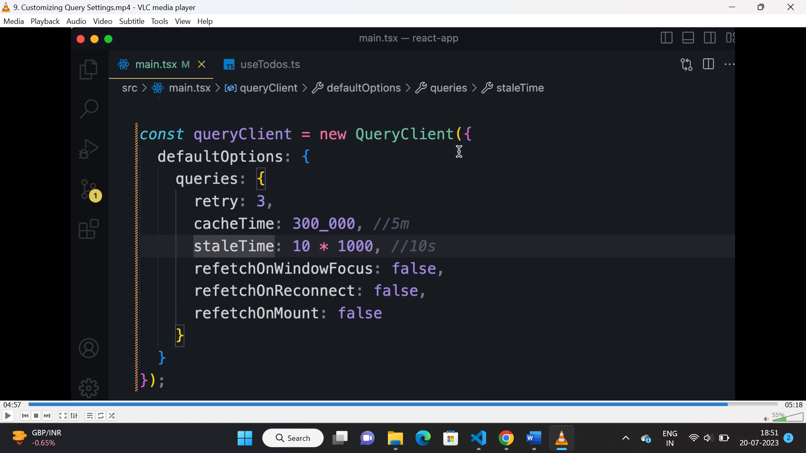

* We can define “queries” object inside “queryClinet”.
* “retry” used to do number of retries after a failed request.
* “cacheTime” is the time upto which fetched data will be preserved in cache after that data will be removed from cache.
* “staleTime” tells how long fetched data will be fresh. After that when we require the same data, the data will be fetched from Api.
* Rest of the property are self explanatory.
* Out of all “staleTime” is used the most.

**Mutating data:**

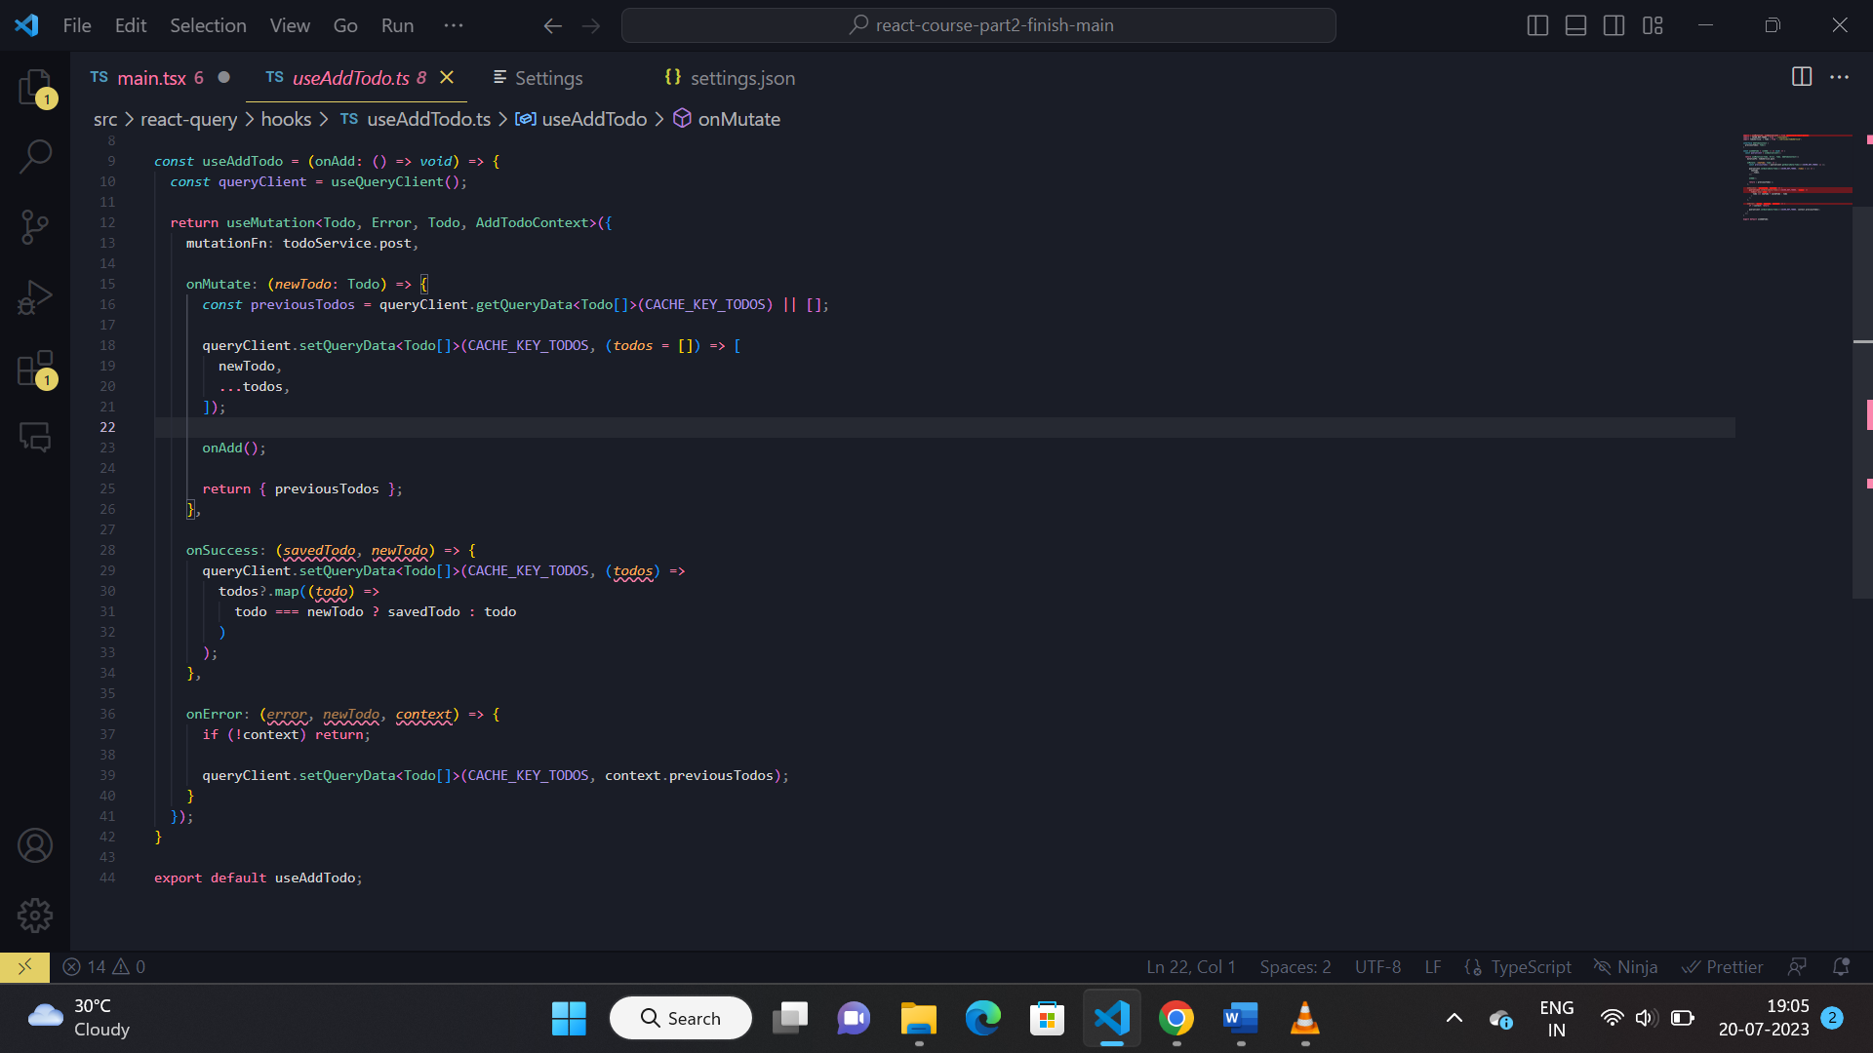

* “useMutation” hook is used for mutating data.
* “onMutate” used when mutation hook starts executing.
* “onSuccess” used when API call is success.
* “onError” used when error is faced.

**useMemo:**

* useMemo is used to memoize or cache a value or result of a calculation which might take longer to calculate.
* **Why:** if calculating result is time taking, then on every rerender it will impct the performance of application so to optimize performance “useMemo” Is used.

Syntax:

**const cachedValue = useMemo(calculateValue, [dependencies])**

**useCallback:**

* useCallback is used to memoize or cache a function which might be complex in nature.
* **Why:** if executing the function is time taking, then on every rerender it will impct the performance of application so to optimize performance “useCallback” Is used.

Syntax:

**Let cachedValue = useCallback(calculateValue, [dependencies])**

**React.Memo:**

* In react when the parent component rerenders, the child component inside it will rerender even if there is no change in the props and state.
* To avoid that situation we use “Memo” HOC, so if there is no change in the props and state the component will not rendre.

**Syntax:**

Export default React.Memo(componentName)

**useLayoutEffect:**

* used to calculate mesurement of UI components before it renders.
* Some time for dynamic content this feature is used.
* Should be avoided coz it hurts performance.

**Lazy suspense:**

* lazy loading is used for performance optimization.
* It spilt the code effect the performance of the application.
* If a code is time taking then it will not load that chunk on initial render of the application, when we navigate to that component then it starts loading.

**Synatx**

**const MarkdownPreview = lazy(() => import('./MarkdownPreview.js'));**

**suspense**

“suspense” component is used to render the fallback text until the component is being loaded.

**Syntax**

**<Suspense fallback={<Loading />}>**

**<h2>Preview</h2>**

**<MarkdownPreview />**

**</Suspense>**

**forwardRef and useImparativeHandle:**

* “ForwardRef” is used to forward the referance of a component to its parent.
* Since the parent will have all access of that child using “ref”, “useImparativeHandle” hook is used to linit or customize the child component acces to the parent.

**Syntax:**

**const MyInput = forwardRef(function MyInput(props, ref) {**

**useImperativeHandle(ref, () => {**

**return {**

**// ... your methods ...**

**};**

**}, []);**

**Create portal:**

Used to render something mostly modals either in body lebel or outside of the div with id “root”.

**Syntax:**

**<div>**

**<p>This child is placed in the parent div.</p>**

**{createPortal(**

**<p>This child is placed in the document body.</p>,**

**document.body or document.getElementById(id)**

**)}**

**</div>**

**Custom hook:**

* Custom hooks are used for code reusability and separation of concern.
* Custom hooks internally have access to “useState” and “useEffect” hooks.

const { useEffect, useState } = require("react");

const useFetch = (url) => {

const [data, setData] = useState([]);

const [error, setError] = useState("");

useEffect(() => {

fetch(url)

.then((data) => data.json())

.then((data) => setData(data))

.catch((err) => setError(err.error));

}, [url]);

return { data, error };

};

export default useFetch;